JODC’s Activities Related to GODAR-WESTPAC

Satoshi SATO
Japan Oceanographic Data Center
Hydrographic and Oceanographic Department, Japan Coast Guard
http://www.jodc.go.jp/, mail@jodc.go.jp

Since its establishment in 1965, Japan Oceanographic Data Center (JODC) has been fulfilling the role of the synthetic marine data bank of Japan. And, JODC has also been carrying out international services as the National Oceanographic Data Center of Japan under the framework of International Oceanographic Data and Information Exchange (IODE) promoted by IOC.
JODC, as the fundamental activities of Japanese National Oceanographic Data Center, has located the oceanographic data stored in paper forms at Japanese research institutes, digitized the data, and made them available for the public.
We present in this paper our activities concerning data rescue and data service, including the publication of several datasets, in recent years.

1. Data Rescue

1-1 Historic Data of Hydrographic Department

The Hydrographic Department of Japan belonged to the Japanese Navy until 1945. Oceanographic Data in those days were already digitized by JODC in the latter half of 1960s, and such digitized data were sent to World Data Centers long before. However, recently, we found that packages of the old documents were left at a dark corner of the warehouse and the historic oceanographic data were recorded in the documents. Some data had already been digitized many years ago, but the most of them had not been digitized yet.
Fig.1
We newly digitized about 12,000 profile data of temperature, salinity, PH, dissolved oxygen, etc. Most of these profile data are from sea surface to 600m or 800m depth.
The distribution of the digitized data is shown in Fig.1. The observation area covered not only the waters around Japanese islands but also the seas near Philippines, Indonesia, and the Marshall Islands. The observations in the area where the Kuroshio flows south of Japan were carried out nearly every month. The number of profiles of each data type is shown in Table 1.
These digitized data were already sent to the World Data Centers for Oceanography, and are also available on J-DOSS (JODC Data Online Service System: http://www.jodc.go.jp/service.htm), which is the online data retrieval system operated by JODC from the year 1995.

Table 1
Observed Year | temperature | salinity | PH | DO | SiO2 | Ocean Current
1931 | 42 | 42 | 42 | 22 | 0 | 0
1933 | 3 | 3 | 3 | 0 | 0 | 1
1939 | 1,559 | 1,522 | 1,504 | 73 | 0 | 2
1940 | 1,887 | 1,887 | 1,877 | 0 | 15 | 27
1941 | 3,117 | 3,117 | 3,110 | 0 | 30 | 80
1942 | 2,425 | 2,417 | 2,416 | 0 | 0 | 95
1943 | 2,334 | 2,332 | 2,256 | 0 | 17 | 123
1944 | 561 | 559 | 558 | 0 | 0 | 11
1945 | 1 | 1 | 1 | 0 | 1 | 0
1946 | 7 | 7 | 7 | 0 | 0 | 0
1947 | 19 | 19 | 19 | 14 | 19 | 0
Total | 11,955 | 11,906 | 11,793 | 109 | 82 | 339

1-2 CTD Data and Bottle Sampling Data by Ocean Research Institute, University of Tokyo

JODC, in collaboration with Marine Information Research Center (MIRC), Japan Hydrographic Association, has digitized the bottle sampling data and CTD data obtained by more than 50 cruises of Hakuho Maru and Tansei Maru of Ocean Research Institute, University of Tokyo from 1967 to 1999.

1-3 Data observed by Hiroshima University

JODC, in collaboration with MIRC, digitized the oceanographic data, which was obtained from the observations in Seto Inland Sea conducted by the Emeritus Professor Tsubota of Hiroshima University as the principal researcher. These observations were carried out by using the training vessel, Toyoshio Maru, of Hiroshima Unversity and the research vessel, Tansei Maru, of University of Tokyo from 1981 to 1991. The total number of data points is more than 500. The parameters obtained by the observations were mainly temperature, salinity, dissolved oxygen, and nutrients. In addition, heavy metals were analyzed at some water sampling sites.

1-4 Data Observed by National Fisheries University

National Fisheries University has two training vessels, Koyo Maru and Ten’yo Maru, which cruise around the world to train the students of fisheries science and ocean mechanical engineering. During the cruises of two vessels, physical and biological ocean observations have been carried out, and the results of the observations have been published as ‘Data of Oceanographic Observations and Exploratory Fishing’ from National Fisheries University. However, the digital data have been missing, so JODC undertook the digitization of the data printed in the reports that were stored in JODC. JODC is now digitizing 1,517 points of data (CTD, BT, and bottle sampling) observed from 1980 to 2000, and will check the digitized data and make them available in near future.
National Fisheries University has provided JODC with the data observed after 2001 in digital form.

1-5 Hourly Sea Level Height at Tide Stations of Hydrographic and Oceanographic Department

Hydrographic and Oceanographic Department (HOD), Japan Coast Guard, has operated about 30 tide stations. The hourly sea level heights at these stations after 1965 have been available on J-DOSS. HOD also holds the data before 1964 in paper tabular forms. JODC newly digitized the hourly sea level heights at 17 tide stations listed in Table 2 with the digitized period. The newly digitized data are now available on J-DOSS.

Table 2
Station | Period | Station | Period | Station | Period
Monbetsu | 1955-1964 | Hachijojima | 1951-1964 | Sasebo | 1950-1964
Ominato | 1952-1964 | Minami-Izu | 1964 | Naze | 1957-1964
Kamaishi | 1953-1964 | Kure | 1952-1956 | Izuhara | 1947-1964
Yokosuka | 1960-1964 | Hiroshima | 1952-1964 | Maizuru | 1947-1964
Kozushima | 1964 | Tokuyama | 1950-1964 | Yokohama | 1962-1964
Miyakejima | 1964 | Moji | 1958-1964

1-6 Historic Tide Data at Palau Ialand

The Meteorological Observatory of South Sea Bureau at Palau Island, which was established by Japanese government before World War II, carried out tide observation at Madarai Breakwater, Palau Island from 1926 to 1939, and the hourly values of sea level height were published as ‘Tidal Observations’ every year. We found that ‘Tidal Observations’ were stored in the libraries of Kyoto University and Hiroshima University, and we got its copies from both libraries. These data reports were forwarded to the Joint Archive for Sea Level (JASL) at Hawaii University, and ask JASL for the digitization.
The data from 1929 to 1936 of these data reports are now available on the website of the JASL.

1-7 Plankton Data in Tokyo Bay

The Chiba Prefectural Environmental Research Center (CPERC) has carried out ocean observations in Tokyo Bay for the detection and prediction of the red tide, about ten times a year. In these observations, it samples sea surface water at 13 observational sites in the bay and species of plankton, especially phytoplankton, in the sample water are identified. JODC has digitized 1,867 points of the plankton data obtained from 1980 to 1994 by CPERC. They will be available on J-DOSS in a few months.

2 Data Service

In order to enhance marine research, exploitation and development by providing various users with oceanographic data and information, JODC operates an online data retrieval system, J-DOSS (JODC Data Online Service System), as well as publishes several datasets, which consist of the oceanographic data from research projects/programs.

2-1 Hokkaido University Long-Term Fisheries and Oceanographic Data Base

Graduate School of Fisheries Science and Faculty of Fisheries of Hokkaido University have carried out oceanographic observations with two training vessels, Hokusei Maru and Oshoro Maru, and the results of observations have been published as ‘Data of Oceanographic Observation and Exploratory Fishing’ every year.
Fig.2
Hokusei Maru III sailed 527,456 miles in 95 cruises over 25 years and was decommissioned at the end the fiscal year 2001. Commemoration of the achievement of Hokusei Maru I, II, and III for over 50 years, JODC and Hokkaido University are processing these data to produce a CD-ROM dataset, ‘Hokkaido University Long-Term Fisheries and Oceanographic Data Base Vol.1’. It contains oceanographic data published in ‘Data of Oceanographic Observation and Exploratory Fishing No.1-45’, from 1953 to 2001, together with high resolution CTD data, which could not be published in paper form. Some data were digitized before and are available on J-DOSS, but others were newly digitized by JODC to include them in the dataset. Fig. 2 shows the distribution of all data points which are contained in the dataset. The observation sites for about 50 years cover wide area in the world, North and South Pacific and Indian Ocean. We believe that the publication of this CD-ROM dataset will contribute the oceanographic research, especially in the North Pacific.

2-2 ECOMIC Dataset

A study program, ECOMIC (Ecology of Coastal Microbial Cycle), was carried out by National Institute for Resource and Environment (NIRE) from 1993 to 1997, in collaboration with University of Tokyo, Shinshu University, and Marine Biological Research Institute of Japan Co. Ltd. On the study of the ecosystem dynamics in Tokyo bay, it is important to understand 1) the mass-transport within the bay, 2) the production/consumption of the biomass, and 3) the ecological communities as the elements of ecosystem. For this study program, water sampling, CTD observation, and plankton sampling were carried out along the long axis of Tokyo Bay, repeatedly. To make available such data to the public, JODC edited and published the ECOMIC Dataset, which contains the documents related to this study program as well as physical, chemical and biological data in Tokyo Bay.

2-3 JGOFS North Pacific Process Study Data Set

JODC has published a DVD Dataset, ‘JGOFS North Pacific Process Study Data Set’. JGOFS (Joint Global Ocean Flux Study) was a core project of IGBP (International Geosphere Biosphere Programme). The purposes of this dataset are to collect the results of marine biogeochemical studies in the North Pacific and to make them available for the further study. This dataset was compiled under the supervision of the North Pacific Synthesis Group of JGOFS, in collaboration with the researchers involved in the related programs. It contains the data from the international research programs in the North Pacific and also the data of the related national programs of Canada, Japan, Taiwan and USA. The data are recorded both in the original format of each program and in the ODV (Ocean Data View) spread sheet. The total volume of the data contained in this dataset reaches 2GB.

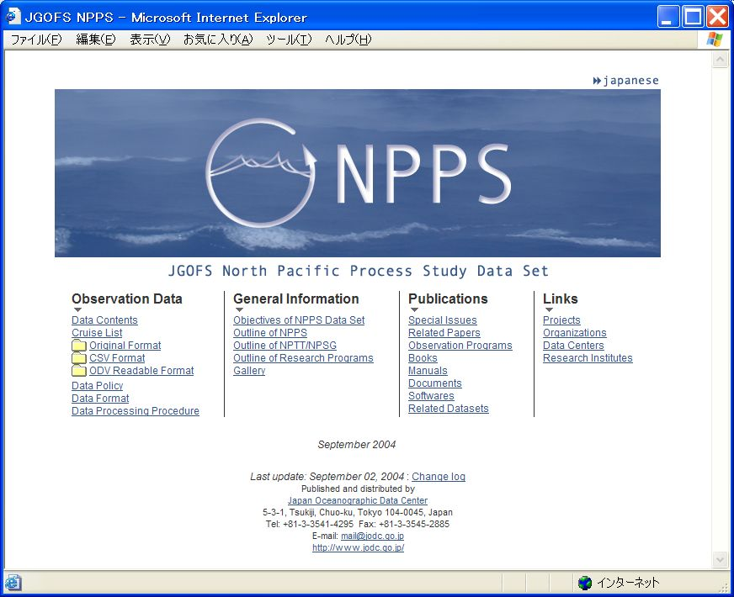

Fig.3 Top page of NPPS Data Set

2-4 J-DOSS (JODC Data Online Service System)

Since 1995, JODC has operated an online data retrieval system, J-DOSS (http://www.jodc.go.jp/service.htm). It provides users with oceanographic data and information managed by JODC through Internet. Those who have the facility to connect with Internet in the world are able to search the data using some keywords and download the oceanographic data that they need from J-DOSS. 12 types of oceanographic data and information (Table 3) are now available on J-DOSS, including some newly digitized data presented in the previous section.
In 2003, more than 27,000 data files were downloaded from J-DOSS in a year, and their total volume reached 25.5GB. Especially, Tide data were downloaded more than 17,000 times a year. About 90% of data were downloaded from the Japanese domain.
The data service of JODC has contributed to the oceanographic studies and the global environmental studies in Japan. For the past 5 years, 1999-2003, 20 papers, which used or analyzed the oceanographic data provided by JODC, were published in ‘Journal of Oceanography’, the journal of the Oceanographic Society of Japan. This number, 20, is 6% of the number of all papers published in ‘Journal of Oceanography’ for the past 5 years, 334.

Table 3
Data/Information | Observed Year | Number of Stations
Serial Station Data | 1874 - 2004 | 3,385,000
Ocean Current Data | 1854 - 2002 | 5,460,000
Tide Data (Hourly Height) | 1947 - 2003 | 125
Marine Organisms Observation Data | 1951 - 1990 | 38,000
500m-grid Bathymetric Data |  | Adjacent Seas of Japan
Statistical Analyzed Result :  Water Temperature (1 degree grid) | Statistical Period  1906 - 2003 | Global
Statistical Analyzed Result :  Salinity (1 degree grid) | Statistical Period  1906 - 2003 | Global
Statistical Analyzed Result :  Ocean Current (1 degree grid) | Statistical Period  1953 - 1994 | Global
National Oceanographic Programs of Japan | 1997 -
Cruise Summary Report | 1996 -
IOC Publications | 1961 -
Oceanographic Abbreviation/Acronym Dictionary

