The Activities of GODAR Project in China
Guo Fengyi
National Marine Data and Information Service
Tianjin, China

A. General Activities

The government of China is actively supporting the GODAR project. The project for rescuing historical marine observation data has been proceeding in China.
For COADS some cooperative projects between China and U.S.A. for digitizing historical marine observed data have been made successfully. Some historical marine data collections have been digitized. These digitized data, such as Maury Collection (1792--1910) and Marine Meteorological Journal (1878—1894) have been merged into the COADS dataset.
For GODAR project the voluntary observing ship collection have been digitized. In order to do more contribution for the GODAR project a new historical marine data rescue project for digitizing German Maury Logbooks (1850-1868) has been discussing between China and U.S.A. Up to now there is still some historical marine observed data that need to be rescued.

B. To Digitize Historical Marine data for COADS

For COADS a long-term cooperation between China and U.S.A. has been proceeding. Some important historical marine observed data have been digitized, especially the Maury Collection and Marine Meteorological Journal. These data were collected 100 years ago. The total amount of the digitized data is more than 300 million observations. These data are very useful for researching the exchange rules of the ocean environment, especially the long-term exchange rules. These data have been merged into the COADS dataset.

1. Maury Collection

(1) Period of Maury Collection
Maury Collection is a historical dataset collected during the period 1792-1910. Figure 1 show the year distribution of the Maury Collection. From the picture it can be known that the most observations were collected in the period 1832-1860.

Figure 1 Year Distribution of the Maury Collection.
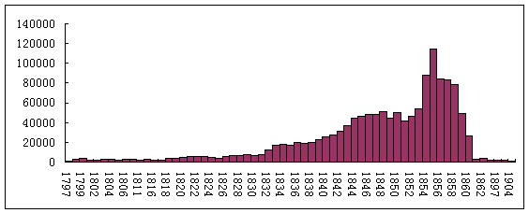
(2) Main Parameters of the Maury Collection
The main parameters of the Maury Collection include Current, Wind, Barometer, Air Temperature, Surface Water Temperature, Forms of Clouds, Weather, Sea State and so on. The bulk of the records in the Maury Collection are effectively daily observations. The interval of most observations is in every two hours. Some interval of observations is 3 times every day.
(3) Amount of the Maury Collection
The amount of digitized and available Maury Collection is 1.5 million records.
(4) Geographical Distribution of the Maury Collection
The geographical distribution of Maury Collection is in the global oceans. Figure 2 show the geographical distribution of the digital data from the Maury Collection that contained a complete latitude and longitude position in the logbook record.

Figure 2 Geographical Distribution of Maury Collection
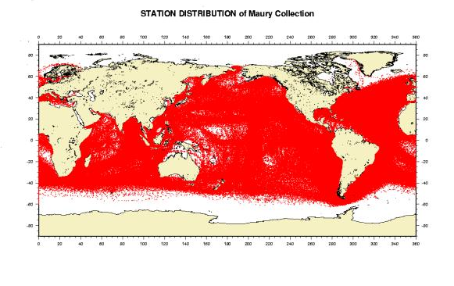
(5) Status
According to the Joint Implementation Plan between the U.S. National Climatic Data Center (NCDC) and the China National Oceanographic Data Center (CNODC), the Maury Collection Data were digitized by China. The work has been finished and the digitized data has been merged into COADS.

2. Marine Meteorological Journal

(1) Period of Marine Meteorological Journal
Marine Meteorological Journal is a historical dataset collected during the period 1878-1894. Most of them were collected in the period 1883-1887. Figure 3 shows the year distribution of the Marine Meteorological Journal.

Figure 3 Year Distribution of the Marine Meteorological Journal.
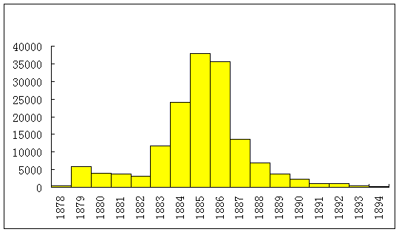

(2) Main Parameters of Marine Meteorological Journal
The main parameters of Marine Meteorological Journal include Current, Wind, Barometer, Air Temperature, Water Temperature, Forms of Clouds, Sea State, Weather and so on. The interval of most observations is in every two hours. Some interval of observations is 3 times every day.
(3) Amount
The amount of Marine Meteorological Journal is 1.8 million records.
(4) Geographical Distribution of Marine Meteorological Journal
The geographical distribution of Marine Meteorological Journal is in the global oceans. Figure 4 shows the geographical distribution of the digital records from the Marine Meteorological Journal that contained a complete latitude and longitude position in the logbook record.

Figure 4 Geographical Distribution of Marine Meteorological Journal
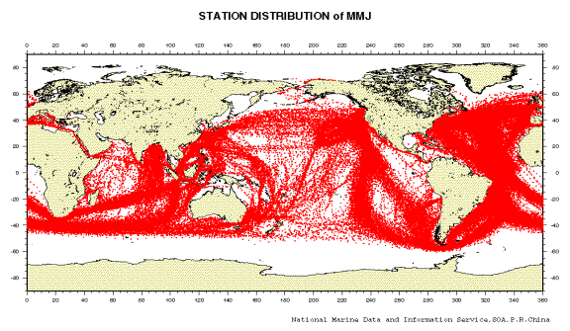
(5) Status
According to the Joint Implementation Plan between the U.S. National Climatic Data Center (NCDC) and the China National Oceanographic Data Center (CNODC), the Marine Meteorological Journal Data were digitized by China. The work has been finished and will be merged into COADS.

C. To Rescue Historical Marine Observation Data for GODAR

In China the Ministry of Science and Technology is actively supporting the GODAR project. The GODAR project has been proceeding. A processing and quality control system for historical marine observed data has have established. The voluntary observing ship collection data have been digitized. Some data have been collected, stored and managed. Some data have been rescuing.
For historical reason some historical marine observed data were recorded on paper and most of these data are managed by different agencies in China. In order to rescue these data, it will take some time to do some work in coordination with the relative agencies. The GODAR project is not finished in China.
In the activities of GODAR project the following work has been done:

1. Analyses of Historical Marine Data

According to our experience, before starting to rescue a historical marine observed collection, the following work need to be done:

(1) To analyze the processed datasets, to be sure that is valuable for digitizing;

(2) To design the relative record formats and codes;

(3) To resolve the relative technical problems arising from the digitized work;

(4) To convert record format into standard format;

(5) To do quality control;
(6) To delete the duplicate records or stations;
(7) To merge the digitized data into a relative database.

2. Preparation for Digitizing Historical Marine Data

For digitizing a historical marine dataset he following preparation work has been done:
(1) To design general principles for digitizing historical marine data
They must be worth for digitizing; They must be complete and reliable; The relative technical problems arising from digitizing work can be resolved; Special oceanographer is responsible for the digitization work; To design a reasonable keying record format.
(2) To design general procedure for digitizing work
To design keying record format; To design relative parameter codes; To convert the original information into keying record format; To do quality control; To convert the keyed data into standard record format.
(3) To resolve special problems for digitizing work
During digitizing a data collection some problems may arise, such as clerical mistakes, systematical errors, special calculation units, unreasonable value and so on. In order to make the digitizing work successful these problems have been resolved before starting the work.
(4) To do pre-processing
Pre-processing work includes designing record format and codes; calculation of various derived parameters; interpolation of standard depths; conversion between pressure and depth; editing a complete user guide.

3. Quality Control of Historical Marine Data

In order to get higher quality, some quality control methods have been developed. In China a quality control system has been developed. This quality control system includes data field verification, data relationship verification and climatological verification. By using this system most serious errors or problems hided in the datasets could be found.

(1) Data field verification

The data field verification performed a variety of automatic checks on individual data fields. By this procedure it can be assured that:

* Each field contains expected data type.

* All data values were written within acceptable ranges.

* All code values were reasonable.

* Mandatory fields were present.
* There is no any illegal character.
(2) Data relationship verification
The data relationship verification evaluated the appropriateness of some data values in relation to other data values. By this procedure it can be assured that each observed value is reasonable.

(3) Climatological verification
This procedure is used to determine the acceptability of the observed values in comparison to existing values within climatological models.

4. Digitization of Voluntary Observing Ship Collection

In China the voluntary observing ship collection have been digitized. The voluntary observing ship collection is a dataset that was observed during the period 1968-1993 by Chinese ships. Most of them were collected in the period 1968-1983. Figure 5 shows the year distribution of the voluntary observing ship collection.

Figure 5 Year Distribution of the Voluntary Observing Ship Collection.
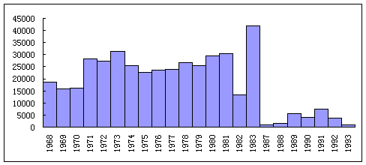

The main parameters include Wind, Barometer, Air Temperature, Surface Water Temperature and Salinity, Wave, Visibility, Forms of Clouds, Sea State, Weather and so on. The bulk of the records are daily observations. The interval of observations is 4 times every day. The amount is 0.4 million records. The geographical distribution is in the global ocean. Most of them are located in the northwest pacific. Figure 6 shows the geographical distribution of the digital records from the Voluntary Observing Ship Collection that contained a complete latitude and longitude position in the logbook record.

Figure 6 Geographical Distribution of Voluntary Observing Ship Collection
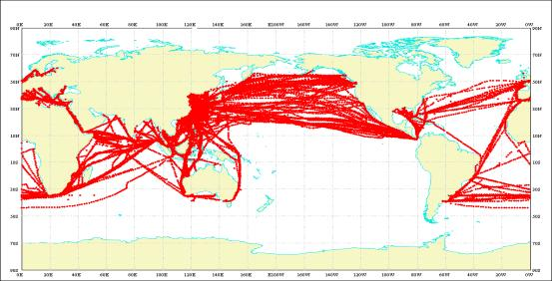

D. Future

Right now the rescue project for digitizing German Maury Logbooks(GML) has been discussing between China and U.S.A. Most of the data were collected during the period 1850-1868 and cover the global oceans. The main parameters of the GML include Current, Wind, Barometer, Air Temperature, Surface Water Temperature, Forms of Clouds, Weather, Sea State and so on. The bulk of the records in the GML are effectively daily observations. There are 870 logbooks in the GML collection. There are about 1 million records. The forms used in the GML are similar to that used in the U. S. Maury Collection. The distribution of the GML is in the global ocean.

References

Guo Fengyi, 1997, The Quality Control of the Maury Collection, WMO/TD-Nº 957.
Fengyi Guo and Dongsheng Zhang, 1998, Study of Quality Control Methods for Ship Observation Data; Marine Science Bulletin, Vol. 17, No. 4, 79-83.
Fengyi Guo, 1999, Digitizing and Quality Control of U.S. Marine Meteorological Journal; CLIMAR 99 WMO Workshop Advances in Marine Climatology.

