SeaDataNet: Pan-European infrastructure for Ocean & Marine Data Management – System for on line integrated data access to distributed heterogeneous systems

prepared for the 2nd International Conference for GODAR-WESTPAC,
November 10-12 2004, JODC, Tokyo, Japan

Catherine MAILLARD ⁽¹⁾, Gilbert MAUDIRE ⁽¹⁾, Dick SCHAAP ⁽²⁾ and SeaDataNet Group
⁽¹⁾ IFREMER, Brest, France, ⁽²⁾ MARIS, Leidschendam, Netherlands

Access to marine data is a key issue for various studies, from the climate change prediction to off shore engineering. However such data, which are currently collected by hundredths of organisations under as many different systems, on board oceanographic vessels or with new automatic observation systems cannot be easily reached. Therefore it is necessary to develop and adopt common standards for data processing and communication and construct a system that network the data producers. This is the objective of SEADATANET. It will be based on a semi-distributed model that incorporates, but enhances, the currently existing infrastructures. The networking in a unique virtual data management system will provide on-line access to integrated data sets from the various sources. The opportunities offered by the recent development of the communication technology makes it possible without modifying the local systems. However the project presents several technical and organizational challenges, which are briefly reported in this paper.

1 Data users’ requirements and existing data management facilities

Whilst each group of users has its own specific data requirements, there is a high degree of commonality in the technical and scientific requirements of the underpinning data delivery support across the whole spectrum. Among these common basic requirements are:
- On line integrated access to data (observations), meta-data (information on data) and products (computed data, plotted data, statistics);
- Access to the most comprehensive and up to date data sets, including real time data from all available dispersed sources;
- Overall consistency and quality level of the data sets;
- Access to value added synthesised data products;
- Adaptability to manage and provide new data types and products;
- Security of long-term data stewardship.
In addition, for each targeted type of users, a marine data management structure should develop specific data products, especially at the regional scale. The key points addressed by the Coastal Ocean Observations Panel of GOOS of the Global Ocean Observing System (GOOS) are to be able to manage multidisciplinary data (currently several hundredths of parameters) of data of different types (in situ, remote sensing and gridded model output), and to provide data services and integrated data access as schematised in Fig.1. These needs are not specific of GOOS, but of many other scientific and engineering projects.

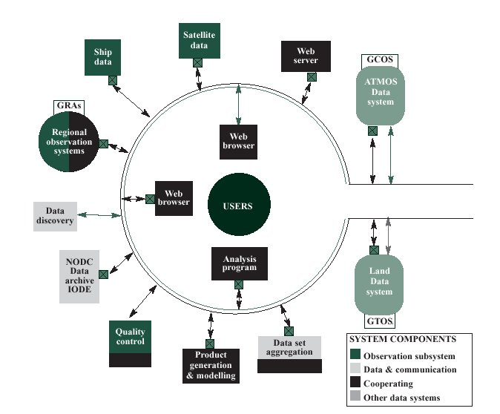
Fig 1: Functional components of the Data Management and Communication System for the coastal module of GOOS.
(from COOP strategic Plan, Modified from the OCEAN.US,2002,p.85).

Around the pan-European seas, many hundreds of institutions are active in collection and processing of data & information for the oceans and European seas. Measurements are made for a wide variety of purposes by research institutions, governmental organizations and private industry. These observational data made in a changing environment are of prime value because they are the reference for any study and, if lost, cannot be remade. Therefore, they should be secured for the future, and it is recognized that this is assured only when they have been submitted to a professional archiving centre. National Oceanographic Data Centres (NODC’s) and major institutes are skilled and actively engaged in data management and can provide such support, for their institutional data sets. They can provide it also for smaller organizations that cannot provide the facilities and manpower necessary to safeguard and manage their data & information on a permanent basis.

The data centres communicate within several thematic and regional networks like the north Atlantic network around ICES, the Baltic network and MEDAR/MEDATLAS for the Mediterranean and Black Sea, and produce joint databases and services. However the continuity is frequently problematic and the lack of common standards hampers the development of common products.

SeaDataNet Objectives

The new SeaDataNet infrastructure aims to ensure continuous on line access to all available data, develop a data management infrastructure of flexible design, allow it to be adapted to future technological and programme changes, and to deliver a high benefit at relatively low cost. More specifically SeaDataNet will provide:
- More data availability and new multidisciplinary integrated data products dedicated to targeted regional priorities;
- Avoiding unnecessary redevelopment of new (and inevitably different) systems for each new project and thus decreasing / optimising the overall costs of data management;
- Inter-operable software tools for real time and delayed mode data management, and technical support to ensure long-term data archiving and up dating;
- Capabilities for developing better and timely integrated data products;
- Critical mass for developing new thematic data management in areas of new parameters, in particular non physical parameters and also to improve the marketing to and the feedback from all the potential types of users;
- Major contribution of the pan-European Data Centres in the data management structure of international programmes, in particular for CLIVAR, ARGO, GOSUD, JGOFS, GODAR and GOSS/JCOMM data structures.

Work programme

The main topics of the work programme are:
- Technological development based on internet for networking the data centres in a unique virtual centre. The SeaDataNet infrastructure will be based on a semi-distributed model that incorporates, but enhances the currently existing infrastructures. Integrated web access to data is considered feasible through a distributed structure based on data standardisation, use of recent communication technology and appropriate hardware equipment. Local interfaces will be connected to common replicated catalogues (possibly in different languages), through a virtual private communication network according to the scheme presented in Fig. 2. It will be developed by step, starting with a short list of expert centres and gradually expanding to other data centres.

- Development of standards for data exchange based on ISO 19115 and IOC/ICES Marine XML (meta-data) and international cooperation

- Organization and monitoring of the networking.

- Development of data and information products adapted to regional needs and various user communities. The data exchange will be first tested on physical and major elements of bio-chemical parameters, enhancing the regional contribution to the international programmes. By steps, the partners will seek to expand the coverage to more and more non-physical parameters.

- Training, education, promotion and capacity building

The time schedule stretches over about 5 year of development before entering a full operational routine phase. The start is expected end of 2005, but depends on the success of a proposal to be submitted in March 2005 to EU to get financial support. Some components like contribution to Marine XML and data standardization and exchange have already been initiated in the frame of the EU projects MEDAR/Medatlas II (regional GODAR for Mediterranean and Black Sea) and Sea Search (common cruise summary reports and data common indexes).

Fig. 2 Sea DataNet Architecture

The partnership

SeaDataNet brings presently together a unique group of 50 major oceanographic institutes from 35 countries bordering the Baltic, the Black Sea, the Mediterranean and the North-East Atlantic (Fig. 3), coordinated by IFREMER (France) to develop a pan-European data grid. All are skilled in management and added value services on a wide range of marine information and data, in physical oceanography, marine biology and marine chemistry. Most partners are operating in their country as national focal point for marine data & information and operate national oceanographic data centres. One partner represents an Oceanographic World Data Centre. As such they are central nodes in their countries with links to other organisations, active in marine research and marine environmental data management.
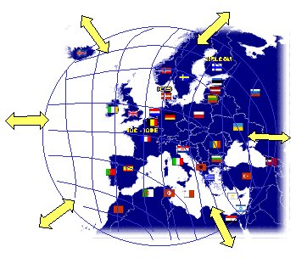
Fig. 3 Nodes of the pan-European datagrid

Conclusion

Joint work on common standards, adaptation of the new communication technology, organizing the networking make possible to provide continuously updated and quality data and value added products. The SeaDataNet project proposes to implement it by step: networking first a core of node data centres already equipped with the necessary facilities, managing the gradual expansion of the network to other data centres, interfacing with other networks such as biological or meteorological data centres and getting appropriate feedback from the users for improving the data services.

This is not an “end to end” systems, but a data management system dedicated to compile, safeguard, standardize and disseminate data, information and products already collected by various sources. It intends also to broaden the users community from the academic community to various other kind of users. It is based on existing networks such the Mediterranean and Black Sea, the Baltic, the Atlantic which produce regional databases, and Sea-Search, which works with IOC and ICES on standards and common catalogues. SeaDataNet intends to enhance these activities to deliver the up to date integrated databases at the international standards of quality. It intends to be opened to other international, regional and thematic networks such as WESTPAC. Similar systems such as the USA DMAC system are also under development and should hopefully be inter-operational when ready. The development and use of international standards and international cooperation, as requested by IOC and JCOMM, should allow the interoperability of the different systems and the overall acceleration of the data and information circulation.

http://www.seadatanet.org/

