GOSUD Global Ocean Surface Underway Data Project

A GOSUD – WESTPAC component

prepared for the 2nd International Conference for GODAR-WESTPAC,
November 10-12 2004, JODC, Tokyo, Japan

R. Keeley ⁽¹⁾, T. Delcroix ⁽²⁾, T. Carval ⁽³⁾, L. Petit de la Villeon ⁽³⁾ and Catherine Maillard ⁽³⁾
⁽¹⁾ MEDS, Ottawa, Canada, ⁽²⁾ IRD / LEGOS, Toulouse, France, ⁽³⁾ IFREMER, Brest, France

Project Overview

The Global Ocean Surface Underway Data (GOSUD) Project is an Intergovernmental Oceanographic Commission (IOC) programme designed as an end to end system for data collected by ships as they traverse the ocean. The goal of the GOSUD Project is to develop and implement a data system for ocean surface data, to acquire and manage these data and to provide a mechanism to integrate these data with other types of data collected in the world oceans. For the purposes of this Project, the data concerned are those collected as a platform is underway from the ocean surface down to about 15m depth.

The objective of GOSUD is to organize the surface underway data that are now collected and to work with data collectors to improve present practices to try to meet the benchmarks of spatial, temporal sampling and data accuracy required to meet GOOS objectives and GODAE requirements. Specifically, the project has the following goals.
a) To build a comprehensive archive for surface underway data. This encompasses data collected by any instrumentation at any time. It will contain sufficient metadata that users will have clear information about accuracy, instrumentation, sampling, etc.
b) To add value to the archive by refining and standardizing existing quality assessment procedures carried out on real time and delayed mode data and documenting both what was done and the results.
c) To provide data and information to users in a timely fashion. At any time after data collection, a user should be able to access the highest quality, and most recent data available. Users will be able to distinguish "levels" of quality in the archives. Users will be able to utilize the data and easily combine them with data from other sources.
d) To work with data collectors to improve the data acquisition systems and to return information to data collectors about the data they provide.
e) To work with scientific organizations interested in surface data to provide products to a broader community.

Ocean salinity is one of the key variables for monitoring and modelling ocean circulation. Therefore the initial focus for the project has been on salinity observations collected by thermosalinograph (Figure 1), but other variables are under active consideration.

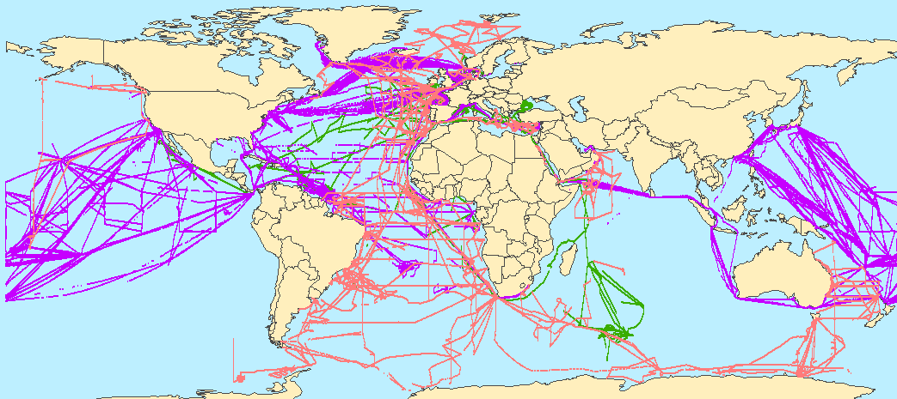

Figure 1. Location of the Sea Surface Salinity data collected at http://www.coriolis.eu.org, the GDAC for GOSUD
it includes data from WOCE SSS, SSS-ORE, Argo/Coriolis (real time)

Data Service

There is an ftp and web site established for the project at http://www.ifremer.fr/sismer/program/gosud/ .

This site delivers global information and data in real time and some local delayed mode data. The data portal gives the position map of the data of the last month (Fig. 2). Other specific requests can be made according to different geographical region (Fig.3), time period and platform identifier. The selected data can be downloaded at two presently available distribution formats :
Argo trajectory format (more on Argo data formats)
Comma separated values (csv) : example (one day of TSG data)

Standardization and Quality Assurance

A preliminary version of the GOSUD Data Manual has been published on the web site. Two key items of the manual : common exchange format and quality control (QC) methodology are still under discussion,.

The present Argo trajectory format seems close to acceptability, for compatibility reasons with Argo exchange format for vertical profiles and trajectories of drifting profilers. Other possible exchange formats are:
TRACKOB : WMO trajectory format – data sent on the GTS
BUFR format and library : WMO trajectory format
MEDATLAS-Time Series Data (autodescriptive ASCII)
WOCE SSS (August 2002)
ASCII table compatible import ODV (Ocean Data View)
Interfaces to input/output data at these formats are under development.

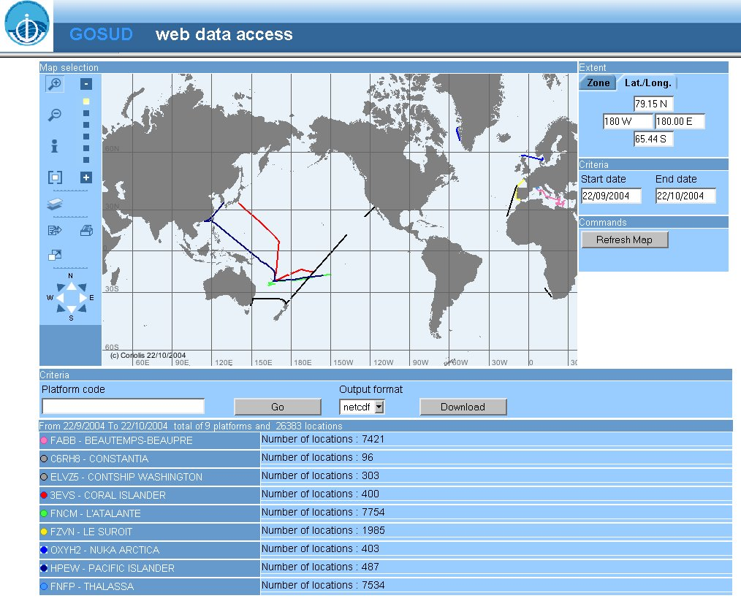
Fig. 2: International GOSUD data server
the first page displays the data of the last month

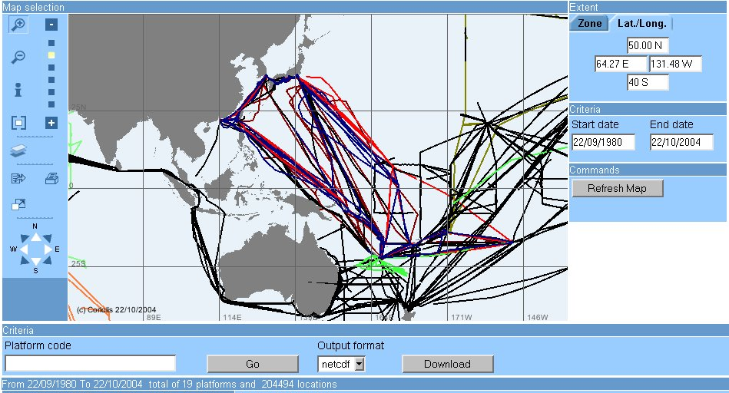
Fig. 3: Position map of the TSG data in the WESTPAC region
Different colors are assigned to each platform

Quality Control

The GOSUD project has adopted the same quality flag scale as used in GTSPP and Argo. This scheme assigns a numeric quality code to position, time and to each observed value. In addition, the data format describes the QC tests that have been applied and which of these failed. This allows a user to decide for themselves if the test procedures meet their requirements.

This scheme is flexible in that it allows tests to be added that are specific for TSG instrumentation such as the comparison of the sea thermometer and the thermometer of the salinograph. The flagging scheme is not used by all international projects and so there is work to do to standardize on a common way to deliver QC information and results

Links and partnership with other projects

GOSUD is primarily filling the role of providing high quality surface data that is important for other projects such as Global Ocean Data Assimilation Experiment (GODAE) and Argo and satellite programmes such as Aquarius and Soil Moisture and Ocean Salinity (SMOS). In delayed mode, the TSG and water samples data are integrated in the World Ocean Atlas produced by GODAR (Fig. 4).

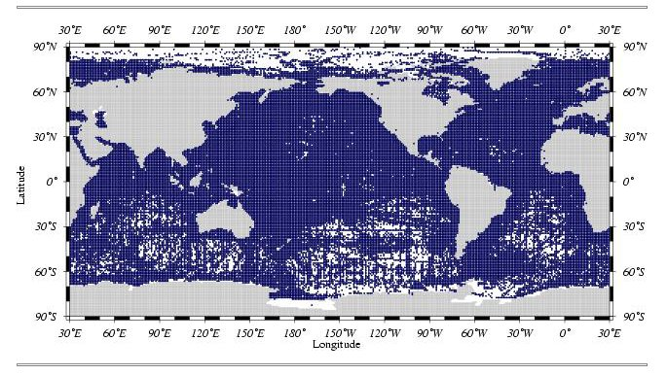
Fig. 4: Surface salinity data from the World Ocean Atlas archives
(Ocean Climate Laboratory, Washington)

Concerning the in-situ data collection, GOSUD is directly related to the Ship of Opportunity Programme (SOOP) of GOOS, as most of the regular lines are measured by these ships. GOSUD is also developing a partnership with the SAMOS (Shipboard Automated Meteorological and Oceanographic Systems) Project to help streamline data acquisition and making contacts with other programs interested in surface observations.

GOSUDis searching to develop partnerships with other related thematic and regional programmes:
GHRSST-PP (Godae High Resolution Sea Surface Temperature Pilot Project)
The GODAE high-resolution sea surface temperature pilot project (GHRSST-PP) has been established to give international focus and coordination to the development of a new generation of global, multi-sensor, high-resolution (~6 hours and 10 km), SST products.
- Project site: http://www.ghrsst-pp.org
- Other sources of SST : http://podaac.jpl.nasa.gov/sst/sst_links.html
The EU Medspiration is a regional project of GHRSST, with higher resolution for the Atlantic and very higher for the Mediterranean.
underway measurements of pCO₂
Information Analysis Centre (http://cdiac.esd.ornl.gov/oceans/pco2inv.html)
WESTPAC could be a leading regional programme of GOSUD.

Conclusive discussion - GOSUD WESTPAC

Collecting and managing surface observation data like proposed in GOSUD, are crucial for many research and monitoring projects related to ocean/atmosphere fluxes. They are also basic for inter-calibrating data from different sources like satellite and in-situ data and to prepare products. Therefore international cooperation and standardization are crucial. Moreover to prepare products, a regional data management activity is also necessary to:
- Specify regional space scales and priorities
- Produce and make data available
- Check for quality and make compatible data from different sources, as the qualification of data lies on preliminary knowledge of statistics, scales of variability, local expertise.

Surface products are already prepared and disseminated on line by WESTPAC DAC such as monthly averages of surface salinity (Fig. 5) in the West Pacific. A WESTPAC contribution for GOSUD would be to enhance this existing activity in an international context, for:
- equipping more ships of opportunity with TSG when possible and participating to inter-calibration experiments
- assembling the real time and delayed mode data collected in the WESTPAC region at the WESTPAC DAC, and insuring the QC
- synchronizing by daily data exchange between WESTPAC DAC and international GOSUD DAC to insure and improve real time data availability for public use
- contributing to the international workshops on surface data standardization for the Pacific Ocean
- preparing and checking data products, statistics and indicators adapted to the regional needs
- advising the international community for enlarging the system to manage other surface parameters collected underway.

In conclusion, a module “surface underway data GOSUD “ in GODAR WESTPAC would be most useful for the development of standards, data exchange and products preparation. WESTPAC DAC already disseminates surface data and products, and this experience would be very valuable if extended for GOSUD in cooperation with the whole WESTPAC community. If it would be of prime value for for GOSUD, it would also benefit to WESTPAC and GODAR by injecting additional data in the region from international sources and being compatible with international standards. Therefore a member of WESTPAC would be very welcome to join the GOSUD Steering Group.

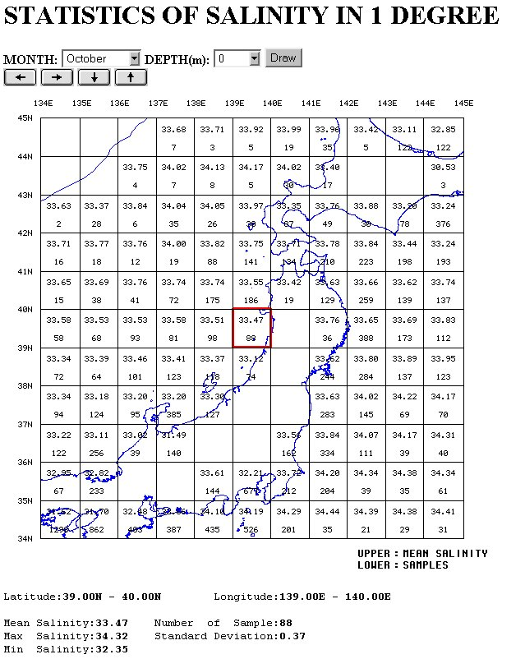

Fig. 5: An example of data product available at JODC:
monthly statistics of surface salinity

