To: mail@jodc.go.jp

On PICES TCODE Activities

Igor Shevchenko
(PICES TCODE Chairman)
October 21, 2004
Abstract

North Pacific Marine Science Organization (PICES)

http://pices.int

PICES, the North Pacific Marine Science Organization, is an intergovernmental scientific organization that was established and held its first meeting in 1992 when the Convention came into force on 24 March 1992 after ratification by three of the five in signatory states, Canada, Japan, and the United States. PICES has already become a major focus for international cooperation in marine science in the northern North Pacific.

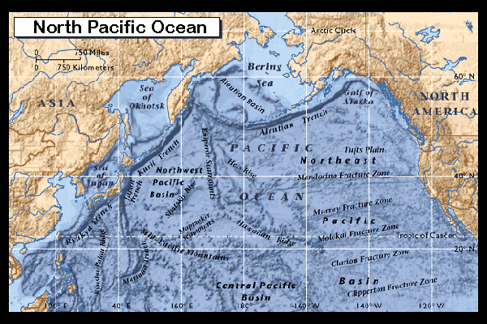
http://www.pmel.noaa.gov/np/mdb/index.html

The present PICES members are Canada, People's Republic of China, Japan, Republic of Korea, Russian Federation, and the United States of America.

The PICES Mission is to promote and coordinate marine scientific research in the North Pacific Ocean in order to advance scientific knowledge of the area concerned and of its living resources.

The PICES goal is to advance scientific knowledge and capacity available to the Contracting Parties, including information on human activities affecting, and affected by marine ecosystems, and to provide a mechanism for collaboration among scientists in addressing timely and critical scientific questions.

The PICES purposes are to:
• Promote and coordinate marine research in the northern North Pacific and adjacent seas especially northward of 30 degrees North.
• Advance scientific knowledge about the ocean environment, global weather and climate change, living resources and their ecosystems, and the impacts of human activities.
• Promote the collection and rapid exchange of scientific information on these issues.

The PICES Structure
The organization structure includes Governing Council, Secretariat, Science Board, Scientific and Technical Committees, Study groups, Working groups, Advisory Panels, Scientific Programs, Task Teams, etc.

The PICES way of doing

- Stratigic Plan: Action Plans for Committees
- Annual Meetings: Theme, Workshops, Scientific Sessions, Poster Sessions, WG/SG/…/Committees Meetings
- Major (Integrating) Scientific Program: CCCC
- High Priority Scientific Programs
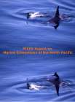 NP Ecosystem Status Report
- Intercessional Activities: Workshops, Symposia, SB/GC Meetings
- PICES Publications: Special Issues of Scientific Journals, PICES Press, PICES Website
- Intern Program
- Capacity Building

PICES Technical COmmittee for Data Exchange (TCODE)

Terms of Reference:
- Identify the data management requirements of PICES;
- Develop strategic plans to meet these requirements;
- Recommend establishment of ad hoc task groups to deal with specific functions of TCODE;
- Review the progress of task groups and provide Annual Reports to Science Board on the work of TCODE; and
- Advise the PICES Secretariat on its data exchange activities.

PICES TCODE way of doing

Collected marine biology data are usually treated as proprietary and no direct access for the information retrieval is available. Metadata bases provide data about data that allow one to understand if some data are of interest for a particular purpose and how to obtain these data. The focus is to promote metadata exchange and act as conduit for information flow.

Annual national report structure (“national infrastructure metadata”)
- key institutes and agencies involved into marine data management activities in the North Pacific,
- key persons/contacts at the institutes and agencies,
- existing data and metadata sets, real-time data sources,
- available data and metadata formats and standards,
- technologies and methodologies for collecting, measuring and enumerating marine organisms,
- DM programs (ongoing and perspective) that underpin marine science programs,
- existing descriptions of intra- and inter-national data exchange polices (regulations, restrictions, etc.),
- software applicable in data collection, visualization and analysis, GIS, digital maps,
- national/regional conferences, workshops on marine data management,
- publications, education materials, etc.

PICES TCODE Projects

TCODE Metadata Inventory: Biological Oceanographic Time Series, Fisheries Time Series, Meteorological Time Series, Physical and Chemical Oceanographic Time Series

http://tcode.tinro.ru

North Pacific Ecosystem Metadatabase (NPEM Bering Sea metadata base)
 http://www.pmel.noaa.gov/np/mdb/index.html
A project on Federating Metadata on the North Pacific Ecosystem was initiated.

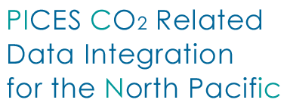

http://picnic.pices.jp/
The PICNIC web site provides the list of cruises linked to opened data and/or metadata bases on CO₂ observations made by the scientists of PICES countries. This is a result of the PICES WG17 and TCODE collaboration.
- 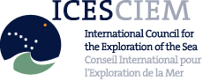
A TCODE member took part at the meeting of the ICES/IOC Study Group on the development of marine data exchange systems using XML (SGXML).
http://www.ices.dk

- 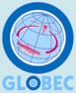GLOBAL OCEAN ECOSYSTEM DYNAMICS

PICES/GLOBEC Data Management Workshop
http://tcode.tinro.ru/w3/report.htm

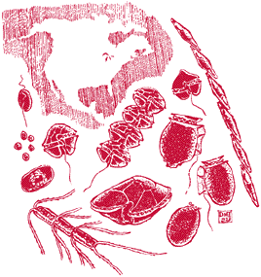
Collaboration with the PICES Harmful Algal Blooms (HAB) Section

