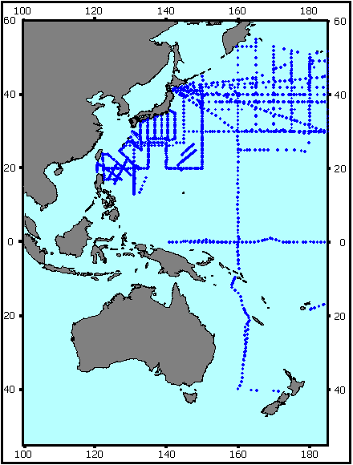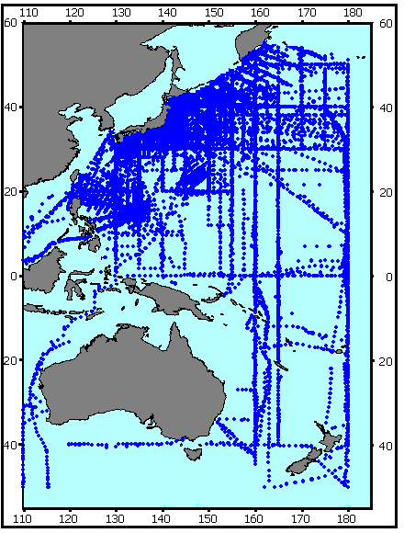

Fig. 3. FERHRI stations digitized for GODAR’1999 (left) and GODAR’2001 (right)

