MEDAR/MEDATLAS 1998-2001: A REGIONAL GODAR CONTRIBUTION BY THE MEDITERRANEAN AND BLACK SEA DATA CENTRE NETWORK

MEDAR Group, presented by Catherine MAILLARD
C. MAILLARD, M. FICHAUT, G. MAUDIRE, C. COATANOAN, IFREMER , Centre de Brest, BP 70, PLOUZANE 29280, FRANCE
R. BOUKORTT, B. BOUDJELLAL, N. EDDALIA, ISMAL, 42321 STAOUELI, ALGER, ALGERIA
J.-M. BECKERS, M. RIXEN, GHER, Univ. de Liège, BE4000, LIEGE, BELGIUM
G. KORTCHEV, INST. METEO. HYDROLOGY, SOFIA 1784, BULGARIA
G. ZODIATIS, CyNODC, Dept Fisheries & Marine Res., NICOSIA 1416, CYPRUS
H. DOOLEY, ICES, Palaegade 2-4, DK-1261, COPENHAGUE K , DENMARK
EL-AGAMI Sherif, ENODC, NIOF, Qayet Bay, El-AnFoshy, ALEXANDRIA, EGYPT
I. OLIOUNINE, UNESCO/COI/IOC, 1, rue Miollis, PARIS 75700, FRANCE
E. BALOPOULOS, A. IONA, A. LYKIARDOPOULOS, P. KARAVREGEKIS, NCMR/HNODC, Hellinikon, ATHENS 16604, GREECE
I. GERTMAN, Y. TSEHTIK, IOLR., Tel Shikmona, P.O.Box 8030, HAIFA 31080, ISRAEL
B. MANCA, A. GIORGETTI, A. MOSETTI, OGS, Borgo Grotta Gigante, P.O.Box 2011, TRIESTE 34010, ITALY
G. MANZELLA, ENEA-CRAM, P.O. Box 316, Forte S. Teresa, LA SPEZIA 19100, ITALY
N. PINARDI, M. ZAVATARELLI, ISAO, Via Gobetti 101, BOLOGNA 40129, ITALY
S. LAKKIS, NAT. CENTRE FOR MARINE SCIENCES, BATROUN, LEBANON
DRAGO Aldo, PHYSICAL OCEANOGRAPHY UNIT, University of Malta, MSIDA, MALTA
A. ORBI, J. LARISSI, S. ZIZAH, INRH, 2, rue Tiznit, CASABLANCA 20000, MOROCCO
N. MIKHAILOV, E. VYAZILOV, A. KUZNETSOV, N. PUZOVA, RIHMI-WDC, 6, Koroleva St., Kaluga Region, OBNINSK 024020, RUSSIA
M.-J. GARCIA, IEO, c. Corazon de Maria 8, MADRID 28002, SPAIN
M. OZYALVAC, F. BERKAY, Seyir ve Hidrografi, Cubuklu, ISTANBUL 81647, TURKEY
- SUVOROV, A. KHALIULIN, MHI, 2, Kapitanskaya Str., SEVASTOPOL 99001,UKRAINE
R. GELFELD, WDCA, NOAA,E/OC53,1315 East-West Highway, 4th Floor,,SILVER SPRING,MD 20910-3282, USA
C. SAMMARI, INSTM,28, rue 2 mars 1934,,2025,SALAMMBO,TUNISIA
V. DIACONU, IRCM,Boulevard Lenin N 300,8700,CONSTANZA,ROMANIA
K. BILASHVILI, Z. SAVANELI, NOC, 21, 50 I. Abashidze str.,TBILISI,GEORGIA
V. DADIC Vlado, IOF, Setaliste I.,MESTROVICA 63,P.O.BOX 114, 21000, SPLIT, CROATIA
D. JOURDAN,CMO,BRESM / CELENV,42, avenue Gaspard Coriolis,31057,TOULOUSE Cedex,FRANCE

The objective of the MEDAR/MEDATLAS II project (Mediterranean Data Archaeology and Rescue of temperature, salinity and bio-chemical parameters, 1998-2001) is to rescue, safeguard and make available a comprehensive data set of temperature, salinity and bio-chemical parameters collected in the Mediterranean and Black Sea, through a wide co-operation of the Mediterranean countries. This project was carried out in the frame of a European Union MAST concerted action (MAS3-CT98-0174 & IC20-CT98-0103) initiated by a consortium of 20 partners from bordering countries and international organisations. The MEDAR network enlarged during the project implementation and involves now 19 National Oceanographic Data Centres or Designated National Agencies for International Exchange of the bordering countries, 3 International Data Centres, 3 Modelling Centres and 2 Intergovernmental Organisations. It involves also cooperation links with the worldwide GODAR project, National Data Centres from other countries carrying sea work in the Mediterranean and Black Sea and the Operational Mediterranean Forecasting Project (MFSPP). This project follows a first pilot project 1994-1996, which released a first database of temperature, and salinity on Cdrom with observed data, analysed data and maps.

The new data rescue has been focused on the following basic parameters: temperature, salinity, oxygen, phosphate, nitrate, nitrite, ammonium, silicate, pH, alkalinity, chlorophyll, hydrogen sulphide (Black Sea), total phosphorus and total nitrogen. These parameters were recognised to be necessary for the following up of the climate change and the calibration of ocean modes. Preliminary information was also available from the World Ocean Atlas (Levitus et al., 1998) to start the quality control procedure. These data have been searched for and compiled from all the scientific laboratories of the partners’ national communities and from the IOC/IODE National Oceanographic Data Centre network outside the Mediterranean and Black Sea (Fig. 1).

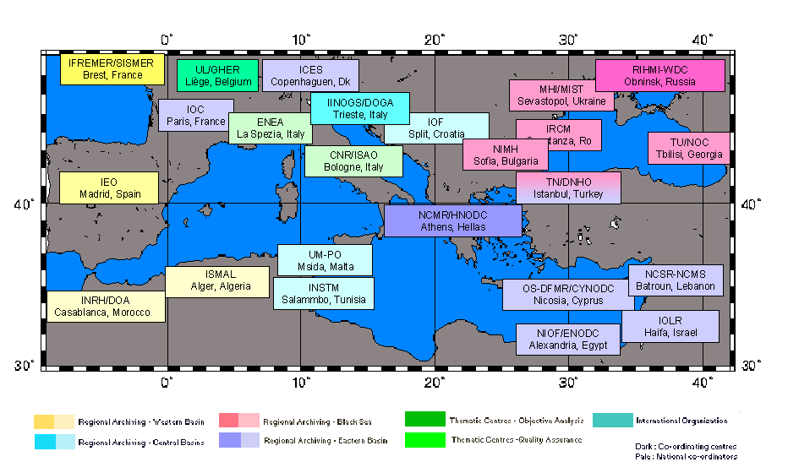
Fig. 1 MEDAR/MEDATLAS Network

The content of the updated database is given in Table I by type of data and Table II for the number of profiles of each parameter.

Table I – MEDAR 2002
Data Type Distribution

Data Type | Number of Profiles
Bottle casts | 88453
CTD | 36054
XBT + MBT | 161890
Thermistors | 29
Total | 286248

Table II – MEDAR 2002
Parameters Distribution
CODE | PARAMETER NAME | NB OF PROFILES
TEMP | SEA TEMPERATURE | 284946
PSAL, SSAL | PRACTICAL SALINITY | 118509
DOX1 | DISSOLVED OXYGEN | 44989
NTRA | NITRATE (NO3-N) | 10588
NTRI | NITRITE (NO2-N) | 10561
AMON | AMMONIUM | 5301

CODE | PARAMETER NAME | NB OF PROFILES
SLCA | SILICATE | 15936
PHOS | PHOSPHATE | 20808
ALKY | ALKALINITY | 2548
PHPH | PH | 14548
CPHL | CHLOROPHYLL-A TOTAL | 4828
HSUL | HYDROGEN SULPHIDE (H2S) | 1843
NTOT | TOTAL NITROGEN | 153
TPHS | TOTAL PHOSPORUS | 2381

Compared to the 1997 release, the volume of available data is doubled. The spatial distribution of the bottle stations and CTD (Fig. 2 and 3) is also improved significantly, except in the middle of the deep basins and on the Lybian shelf. With the addition of the Mbt and Xbt profiles, the temperature observations allow to compute monthly and seasonal climatologies. Salinity and Dissolved Oxygen distributions still allow computing seasonal climatologies, however the southern part of the Mediterranean is not well covered. The coverage of the nutrients decreases dramatically from phosphate, which is considered by the biologists as a control parameter of the biota (20808 profiles, Fig. 3) to total nitrogen (153 available profiles only). H2S is measured only in the Black Sea, in relation with the lack of oxygen in the subsurface layers, even if the deep inflow of Mediterranean water injects some oxygen at depth near the Bosphorus Straits.

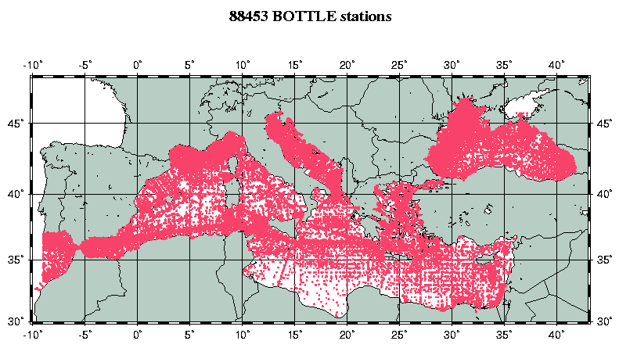

Fig. 1 : Distribution of the Bottle stations in MEDAR Database

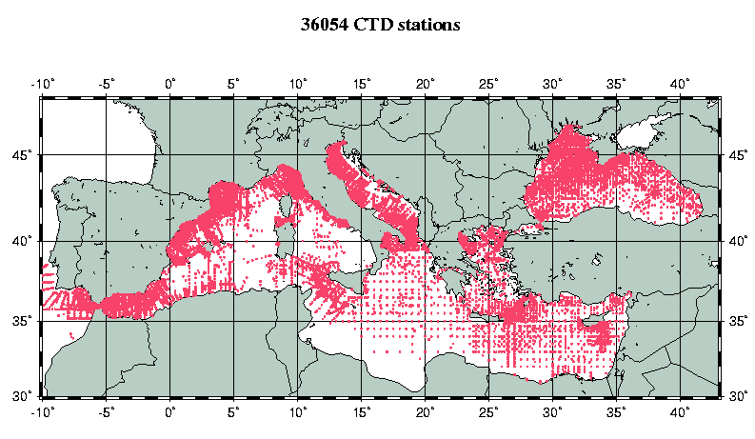

Fig. 2 : Distribution of the CTD stations in MEDAR Database

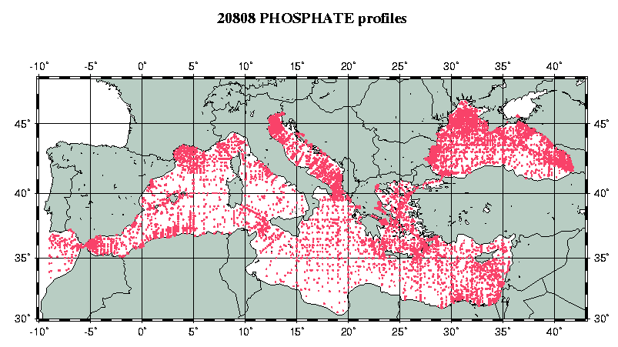

Fig. 3 : Distribution of Phosphate profiles in MEDAR Database

These data have been checked for quality by compatible and coherent procedures based on the international standards published by IOC and CEC/MAST (1993) and described in the common MEDAR protocol (MEDAR Group 2001). The methodology includes automatic and visual checks for duplicates, location and date (QC1, fig. 4) and data points (QC2, fig. 5).

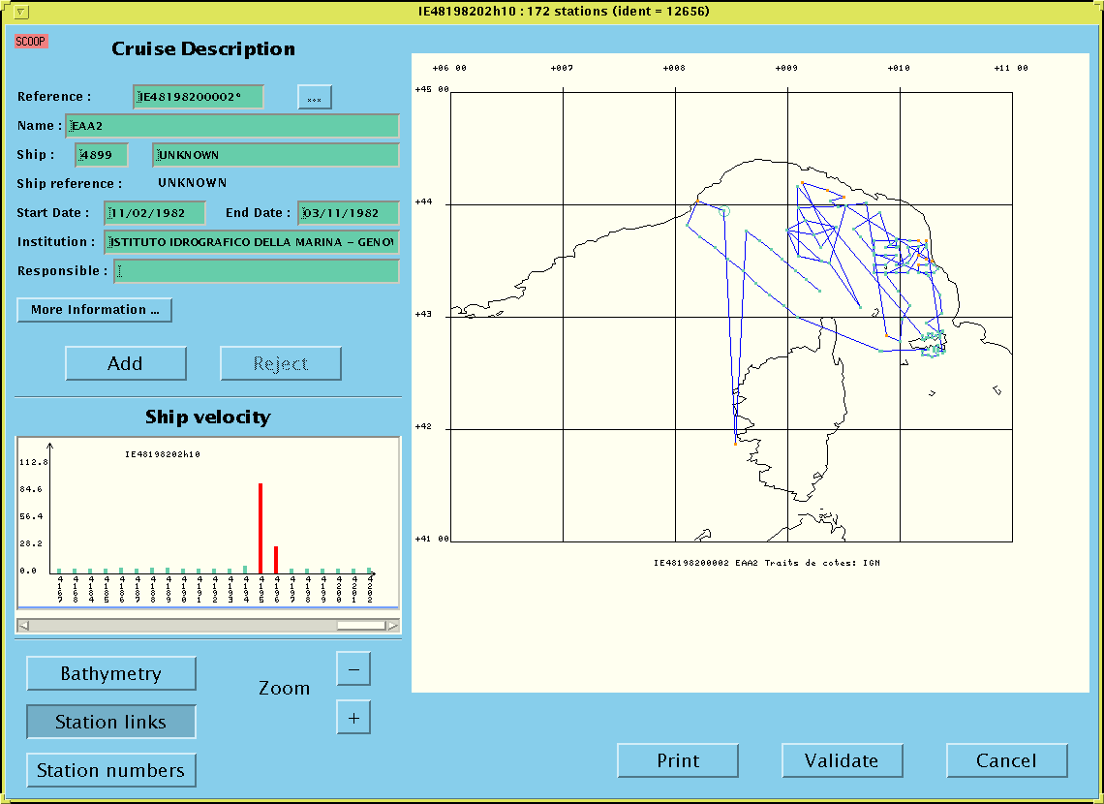

Fig. 4: Check of the location, date and duplicates

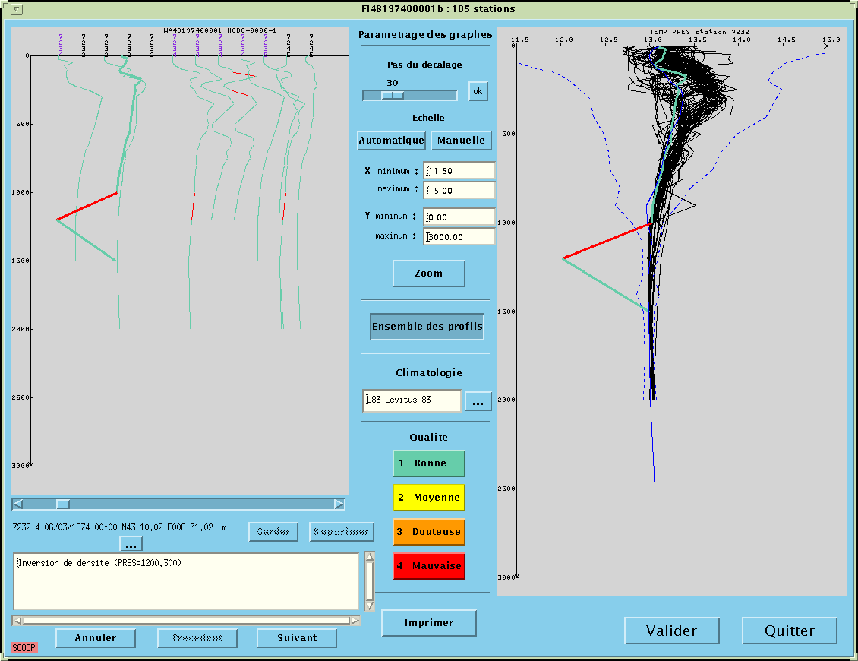

Fig. 5: Check of the data points

This Quality Checking has been made in Four Regional Data Qualification Centres, respectively in Obninks for the Black Sea, Athens for the Eastern Basin, Trieste for the Central Basins and Madrid for the Western Basin, by close cooperation of the national and regional experts.
Copies of regional data sets have been assembled at the Assembling Centre, where a final check has been performed for format and duplicates, and some random checks in addition. Remaining problems have been solved in collaboration with the regional centres. One critical problem was the duplicates in the historical data sets. The data without outliers have been interpolated at vertical standard levels and transferred to the Analysis Centre, where an objective analysis has been performed to get reference climatological fields, horizontal maps (Fig. 6) and vertical sections.( Fig. 7) of all parameters. The computations are made monthly, and for some specific areas with higher space resolution. However the results can be robust only when the space and time data coverage is sufficient.

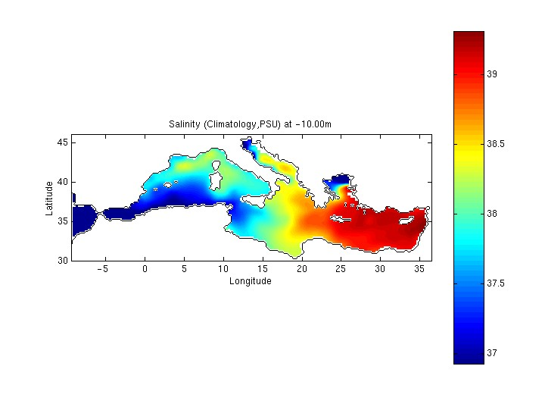

Fig. 6 : Average Salinity Distribution at 10 dbar from MEDAR Database

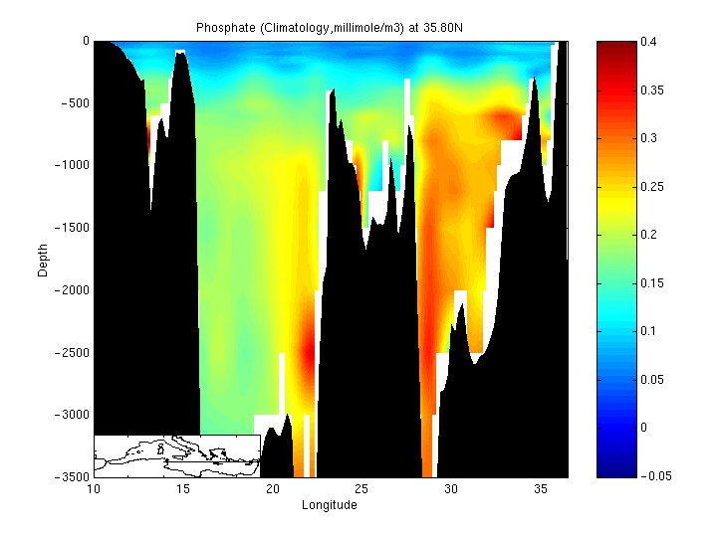
Fig. 7 : Average Phosphate Vertical distribution at 35.80 N from MEDAR Database

These results: , meta-data, observed data, analysed data, maps and software will be published on a set of four Cdroms (MEDAR Group, 2002) and made available for dissemination at each Data Centre of the network. It is expected that they will provide a useful tools for the various kinds of potential users like modellers and experimental scientists, teachers and engineers., as was already the 1997 product. It is also noticeable that, sharing the knowledge and know-how among the participants was an important supplementary result of the project. MEDAR certainly contributed to enhance the overall capacity of the Mediterranean and Black Sea data centres network, in oceanographic data management, and it is a very important issue, as an important volume of new data is expected in the years to come, both from classical oceanographic cruises and from operational oceanography real time data collection systems.

If the results of the present project seems promising, the data rescue and the network needs to remain active and there remain also gap to fill and new challenges. Data are still missing for several critical nutrients, and the quality checks, which are based on the pre-existing knowledge of the distributions, are limited. It is of paramount importance to integrate recent data collected in field projects carried out during the last past years, and to offer faster access to data to the users. Other data types like surface data, current data, and carbon cycle data should also be integrated in the database. Accordingly a new data management concerted action is in preparation for the 2002-2004 period, with a priority of facilitating the on line data access to the users and to improve the quality control procedure of the nutrients. Still the best data management is not sufficient to produce data in the region void of data, especially in the middle of the basins and along the Southern Mediterranean coasts, and it is hoped that more sea monitoring programmes will be also undertaken in the region.

References

CEC/DG XII, MAST and IOC/IODE, 1993. Manual of Quality Control Procedures for validation of Oceanographic Data. UNESCO Manual and Guides N° 26, 436 P.
Levitus, S., T.P. Boyer, M.E. Conkright, T. O' Brien, J. Antonov, C. Stephens, L.
Stathoplos, D. Johnson, R. Gelfeld, 1998: NOAA Atlas NESDIS 18,World Ocean
Database 1998: VOLUME 1: INTRODUCTION, U.S. Gov. Printing Office, Wash.,
D.C., 346pp + set of Cdroms.

MEDAR Group, 2001. Medar-Medatlas Protocol (Version 3) Part I: Exchange Format and Quality Checks for Observed Profiles; Rap. Int. IFREMER/TMSI/IDM/SIS002-006, 50 P.

MEDAR Group, 2002. MEDAR/MEDATLAS 2001 Database. Mediterreanean and Black Sea cuise Inventory, Observed Data, Analysed Data and Climatological Atlas (4 Cdrom, in preparation).

