French Contribution to GODAR/WEST PACIFIC

Catherine Maillard, Michèle Fichaut, Loic Petit de la Villeon, Vincent Bernard
SISMER, IFREMER Centre de Brest, BP 70, 29280 Brest Cedex, France
www.ifremer.fr/sismer

SISMER (Scientific Information System for the Sea) is a service of IFREMER and the French National Oceanographic Data Centre in charge of international oceanographic data exchange in the frame of UNESCO/IOC IODE program.

France contributes to GODAR/WESTPAC by transmitting the hydrographic data collected in national projects or project carried out in cooperation with other institutes. It contributes also to the international ARGO/CORIOLIS data management structure in which a substantial number of temperature (and to some extend salinity) profiles are made publicly available on internet in real time or near real time. For the surface data, SISMER contributes to a new initiative started in IODE to manage the surface salinity data from thermosalinometer both in real time and delayed mode. France contributes also to other regional GODAR, especially to the Mediterranean and Black Sea MEDAR project.

1. French Data transmitted to GODAR in the West Pacific

174 Data sets have been transmitted to GODAR:
50 CTD cruises = 2850 stations from1982 to1999 (fig1)
124 bottle cruises = 4037 stations from 1957 to 1996 (fig 2)

This represents a total of total 6887 stations from the 142 inventoried in annex (the same cruise can have one CTD+ one bottle data set). Most of these cruises are repeated cruises, carried out by the public research institute IRD (Institute of Research for the Development). All the data have been reformatted in a unique ASCII auto descriptive format (MEDATLAS) at SISMER and checked for quality according to IOC and EU/MAST recommendations.

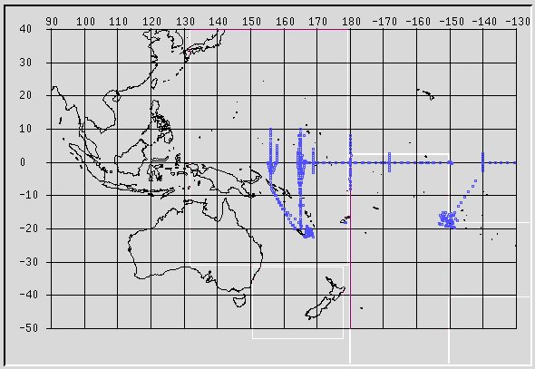

Fig. 1 Distribution of the CTD

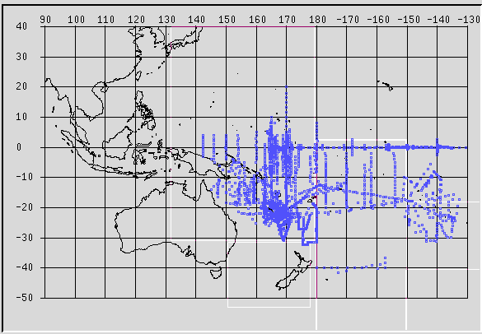

Fig. 2: Distribution of the Bottle casts

2. ARGO Data in the West Pacific

The international real time data archived by the ARGO/CORIOLIS data centre in 2001 are (fig.3):

- for the whole Pacific Ocean: 77 431 profiles (12287 BA + 65144 TE ) from GTS

- for the region 60N -30 S and W120 E 150: 54591 profiles (9456 BA + 45135 TE)

All these data are loaded in a RDBS system and cross-checked for quality. They are disseminated on WWW in ARGO/NetCdf format or ASCI/MEDATLAS. In the forthcoming month, the TOGA/WOCE/CLIVAR database and this database will be merged to improve the data access to users. For the ARGO floats, a unique tagging system has been adopted, but this is not the case for the other data. This is a critical item for the historical data because it loads the quality check task with a time consuming search for duplicates.
http://www.coriolis.eu.org/coriolis/cdc/

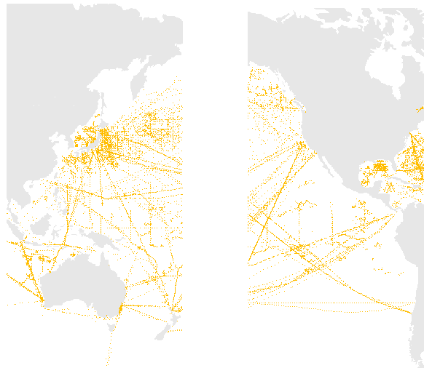
Fig 3. Temperature profiles received in real-time at the ARGO/CORIOLIS Data Centre

3. Underway Surface salinity Data

The surface data seem to interest more and more scientists, including the satellite community. An IODE Steering Group for Underway Sea Surface Salinity Data Archiving Pilot Project was established during IODE-XVI and discussed at JCOMM. The first meeting was held in November 2001 in Brest. Three working groups were defined to work by email for a practical work plan:
1-Data Collection
2-Transfer, Processing, Archiving
3- Products
The results of the working groups will be discussed in the 2002 meeting in Ottawa. According to JCOMM recommendation, Cooperation is searched with other groups starting initiatives with surface data, especially temperature, current and nutrients.

France is contributing to the project writing and to archiving in real time the data from thermosalinograph of the IFREMER vessel. These data will be available on the ARGO/CORIOLIS web site in the forthcoming months. The historical data will be made available by step, depending on the local possibilities because they need further processing (merging the navigation, calibration with CTD data). The data without calibration values will not be disseminated.

Annex

Hydrographic cruises carried out in the West Pacific Ocean from French sources

CRUISE | START | SHIP | LABORATORY
NOUMEA 5 | 30-08-1999 | ALIS | IRD NOUMEA
SUVA 1 | 20-07-1998 | ALIS | IRD NOUMEA, University of the South Pacific (USP)
NOUMEA 1 | 25-05-1998 | ALIS | IRD ( NOUMEA), Universite de Perpignan
ECOTAP 18 | 17-07-1997 | ALIS | EVAAM (Etablissement pour la Valorisation des Activites Aquacoles et Maritimes) - IFREMER - IRD
ECOTAP 13 | 03-03-1997 | ALIS | EVAAM (Etablissement pour la valorisation des activites aquacoles et maritimes) - IFREMER - IRD
ECOTAP 10 | 11-10-1996 | ALIS | IRD et IFREMER PAPEETE, EVAAM
ECOTAP 09 | 16-08-1996 | ALIS | IFREMER PAPEETE, IRD PAPEETE, EVAAM, CPS NOUMEA
ECOTAP 07 | 17-04-1996 | ALIS | IRD PAPEETE et MONTPELLIER, EVAAM
ECOTAP 06 | 19-02-1996 | ALIS | IFREMER PAPEETE, IRD PAPEETE, EVAAM
EBENE | 21-10-1996 | ATALANTE | IRD, INSU-CNRS(Banyuls,Brest,Villefranche/Mer), COM Marseille, PMEL-NOAA/SEATTLE, Univ SHIZUOKA/HAWAI
ECOTAP 03 | 16-10-1995 | ALIS | IRD SAN DIEGO, IRD PAPEETE, EVAAM
ECOTAP 01 | 10-07-1995 | ALIS | IFREMER PAPEETE, IRD PAPEETE
FLUPAC | 22-09-1994 | ATALANTE | IRD NOUMEA, LPCM Paris, CNRS Gif-sur-Yvette, CNRS Banyuls, UBO Brest
EQUALIS | 03-11-1992 | ALIS | IRD, Universite d'Hiroshima (Japon), CSIRO de Canberra (Australie)
COARE 156-04 (POI) | 01-12-1992 | NOROIT | IRD
COARE 156-03 | 05-09-1992 | NOROIT | IRD,PMEL/NOAA,Universites de Hawai,Colombia,Taiwan
SURTROPAC 17 | 06-08-1992 | NOROIT | IRD
COARE 156-02 | 20-02-1992 | NOROIT | IRD
SURTROPAC 16 | 19-01-1992 | NOROIT | IRD
COARE 156-01 | 20-08-1991 | NOROIT | NOAA/PMEL,IRD(NOUMEA),Universite d'Hawai
SURTROPAC 15 | 18-07-1991 | NOROIT | IRD
SURTROPAC 14 | 11-03-1991 | NOROIT | IRD
ALIZE 91 (LEG 1 ET LEG 2) | 02-01-1991 | NOROIT | CNRS,IRD,UPMC,IFREMER,METEO France,FSU,PMEL
SURTROPAC 12 | 28-06-1989 | SUROIT | IRD,NOAA/PMEL (Seattle)
SURTROPAC 13 | 29-11-1989 | SUROIT | IRD,PMEL LODYCSCRIPPS
PROPPAC 4 | 30-10-1989 | SUROIT | IRD,CNRS,CSIROMBARI
SURTROPAC 11 | 04-01-1989 | CORIOLIS | IRD
SURTROPAC 10 | 12-06-1988 | CORIOLIS | IRD,PMEL,NOAA (SEATTLE , USA)
PROPPAC 3 | 11-09-1988 | CORIOLIS | IRD
PROPPAC 2 | 27-03-1988 | CORIOLIS | IRD
SURTROPAC 9 | 15-01-1988 | CORIOLIS | IRD
PROPPAC 1 | 08-09-1987 | CORIOLIS | IRD
PROPPAC 1 | 08-09-1987 | CORIOLIS | IRD
SURTROPAC 8 | 01-07-1987 | CORIOLIS | IRD
SURTROPAC 7 | 08-01-1987 | CORIOLIS | IRD,PMEL/NOAA (SEETLE-USA)
SURTROPAC 06 | 15-06-1986 | CORIOLIS | IRD, PMEL (SEATTLE)
SURTROPAC 05 | 08-01-1986 | CORIOLIS | IRD
SURTROPAC 03 | 09-01-1985 | CORIOLIS | IRD NOUMEA
SURTROPAC 04 | 27-06-1985 | CORIOLIS | IRD (NOUMEA), PMEL (Seattle, USA)
SURTROPAC 02 | 03-08-1984 | CORIOLIS | IRD NOUMEA
PREFIL 10 | 29-08-1984 | CORIOLIS | IRD NOUMEA
PREFIL 9 | 09-05-1984 | CORIOLIS | IRD NOUMEA
SURTROPAC 01 | 09-01-1984 | CORIOLIS | IRD NOUMEA
PREFIL 8 | 03-02-1984 | CORIOLIS | IRD NOUMEA
PREFIL 7 | 08-11-1983 | CORIOLIS | IRD NOUMEA
PREFIL 6 | 07-09-1983 | CORIOLIS | IRD NOUMEA
PREFIL 5 | 12-04-1983 | CORIOLIS | IRD NOUMEA
PREFIL 4 | 24-01-1983 | CORIOLIS | IRD NOUMEA
PREFIL 3 | 08-12-1982 | CORIOLIS | IRD NOUMEA
PREFIL 2-PROCAL | 06-05-1982 | CORIOLIS | IRD NOUMEA
PREFIL 1-PROCAL | 11-03-1982 | CORIOLIS | IRD NOUMEA
PROSGERMON 82 | 11-02-1982 | CORIOLIS | IRD NOUMEA, IFREMER
VALTRACOR I - NOUMEA PAPEETE81 | 15-06-1981 | CORIOLIS | IRD NOUMEA
HYDROTHON 04 | 31-01-1981 | CORIOLIS | IRD NOUMEA
VALTRACOR II - PAPEETE NOUMEA81 | 24-07-1981 | CORIOLIS | IRD NOUMEA
HYDROTHON 07 | 16-11-1981 | CORIOLIS | IRD NOUMEA
HYDROTHON 05 | 02-06-1981 | CORIOLIS | IRD NOUMEA
HYDROTHON 06 | 07-08-1981 | CORIOLIS | IRD NOUMEA
CF8004 | 31-03-1980 | VAUBAN | IRD NOUMEA
CF8001 | 13-01-1980 | VAUBAN | IRD NOUMEA
CIRCAL 11-80 | 27-05-1980 | VAUBAN | IRD NOUMEA
CIRCAL 09-80 | 03-03-1980 | VAUBAN | IRD NOUMEA
CIRCAL 08-80 | 21-01-1980 | VAUBAN | IRD NOUMEA
CF7906 | 18-11-1979 | VAUBAN | IRD NOUMEA
CF7904 | 15-10-1979 | VAUBAN | IRD NOUMEA
CF7903 | 02-09-1979 | VAUBAN | IRD NOUMEA
CF7902 | 01-04-1979 | VAUBAN | IRD NOUMEA
CIRCAL 07-79 | 26-11-1979 | VAUBAN | IRD NOUMEA
CIRCAL 06-79 | 25-10-1979 | VAUBAN | IRD NOUMEA
HEBRIDES 01 | 25-01-1979 | VAUBAN | IRD NOUMEA
SOP1-CORIOLIS | 03-02-1979 | CORIOLIS | IRD NOUMEA, METEOROLOGIE NATIONALE
SOP II-CORIOLIS | 23-05-1979 | CORIOLIS | IRD NOUMEA, ETABLISSEMENT D'ETUDES ET DE RECHERCHES METEOROLOGIQUES PARIS
HYDROTHON 03 | 18-06-1979 | CORIOLIS | IRD NOUMEA
HYDROTHON 02 | 22-02-1979 | CORIOLIS | IRD NOUMEA
CF7802 | 30-03-1978 | VAUBAN | IRD NOUMEA
CF7801 | 16-01-1978 | VAUBAN | IRD NOUMEA
CIRCAL 03-78 | 27-11-1978 | VAUBAN | IRD NOUMEA
HYDROTHON 01 | 02-07-1978 | CORIOLIS | IRD NOUMEA
CIRCAL II | 30-10-1978 | VAUBAN | IRD NOUMEA
CIRCAL I | 19-06-1978 | VAUBAN | IRD NOUMEA
THON AUSTRALES 01 | 01-02-1978 | CORIOLIS | IRD NOUMEA
CF7701 | 16-06-1977 | VAUBAN | IRD NOUMEA
SAMOA I | 05-11-1977 | CORIOLIS | IRD NOUMEA
ECOTON COR 7704 | 29-06-1977 | CORIOLIS | IRD NOUMEA
GORGONE III | 15-09-1977 | CORIOLIS | IRD NOUMEA
DANAIDES II | 05-01-1977 | CORIOLIS | IRD NOUMEA
EPONITE II | 21-08-1976 | CORIOLIS | IRD NOUMEA
ALIOPEE | 03-08-1975 | NOROIT | IRD NOUMEA
GORGONE II COR 75-03 | 07-04-1975 | CORIOLIS | IRD NOUMEA
MINEPO II | 05-07-1974 | CORIOLIS | IRD NOUMEA
73600511 | 14-11-1973 | VAUBAN | IRD NOUMEA
HB7301- NOUMEA PAPEETE73 | 07-04-1973 | CORIOLIS | IRD NOUMEA
NIXO007 TRANSIT PAPEETE-NOUMEA73 | 25-02-1973 | NOROIT | IFREMER, IRD NOUMEA
DIAPHUS 12 B-C | 04-10-1973 | CORIOLIS | IRD NOUMEA
MINEPO I | 11-07-1973 | NOROIT | IRD NOUMEA
71602111 | 10-02-1971 | BOUSSOLE
FOC I | 19-01-1971 | CORIOLIS | IRD NOUMEA
EPONITE 1 | 20-08-1970 | CORIOLIS | IRD NOUMEA
70408111 | 23-01-1970 | CORIOLIS
CARIDE 4-CARIDE 5 | 25-06-1969 | CORIOLIS | IRD NOUMEA
CARIDE 3 | 05-02-1969 | CORIOLIS | IRD NOUMEA
CARIDE 6-CB6903 | 26-11-1969 | CORIOLIS | IRD NOUMEA, IFREMER BREST
CYCLONE 7 | 10-04-1968 | CORIOLIS | IRD NOUMEA
CARIDE 1-CARIDE 2 | 13-09-1968 | CORIOLIS | IRD NOUMEA
FIXE | 25-03-1967 | CORIOLIS | IRD NOUMEA
CYCLONE 6 | 18-08-1967 | CORIOLIS | IRD NOUMEA
CYCLONE 5 | 05-07-1967 | CORIOLIS | IRD NOUMEA
CYCLONE 4 | 30-05-1967 | CORIOLIS | IRD NOUMEA
CYCLONE 3 | 19-04-1967 | CORIOLIS | IRD NOUMEA
CYCLONE 2 | 15-03-1967 | CORIOLIS | IRD NOUMEA
BORA 2 | 04-03-1966 | CORIOLIS | IRD NOUMEA
BORA 3 | 10-06-1966 | CORIOLIS | IRD NOUMEA
BORA 4 | 20-09-1966 | CORIOLIS | IRD NOUMEA
CYCLONE 1 | 21-11-1966 | CORIOLIS | IRD NOUMEA
65600711 | 13-01-1965 | DUNKERQUOI
BRISANTS | 21-08-1965 | CORIOLIS | IRD NOUMEA
BORA 1 | 26-11-1965 | CORIOLIS | IRD NOUMEA
BOULARI 6-CM6207 | 30-09-1962 | ORSOM III | IRD NOUMEA, IFREMER BREST
BOULARI 5-CM6206 | 24-09-1962 | ORSOM III | IRD NOUMEA, IFREMER BREST
BOULARI 4-CM6205 | 15-08-1962 | ORSOM III | IRD NOUMEA, IFREMER BREST
BOULARI 3-CM6204 | 02-08-1962 | ORSOM III | IRD NOUMEA, IFREMER BREST
BOULARI 2-CM6203 | 29-07-1962 | ORSOM III | IRD NOUMEA, IFREMER BREST
BOULARI 1-CM6202 | 16-07-1962 | ORSOM III | IRD NOUMEA, IFREMER BREST
BOULARI 1 | 31-01-1962 | ORSOM III | IRD NOUMEA, IFREMER BREST
ST VINCENT 9 - CM6109 | 26-12-1961 | ORSOM III | IRD NOUMEA, IFREMER BREST
ST VINCENT 8 - CM6108 | 28-11-1961 | ORSOM III | IRD NOUMEA, IFREMER BREST
ST VINCENT 6- CM6106 | 16-08-1961 | ORSOM III | IRD NOUMEA, IFREMER BREST
ST VINCENT 5 - CM6105 | 19-07-1961 | ORSOM III | IRD NOUMEA, IFREMER BREST
ST VINCENT 4 - CM6104 | 18-06-1961 | ORSOM III | IRD NOUMEA, IFREMER BREST
ST VINCENT 3 - CM6103 | 20-05-1961 | ORSOM III | IRD NOUMEA, IFREMER BREST
ST VINCENT 2 - CM6102 | 21-04-1961 | ORSOM III | IRD NOUMEA, IFREMER BREST
ST VINCENT 1 - CM6101 | 22-03-1961 | ORSOM III | IRD NOUMEA, IFREMER BREST
DILLON-CM6003 | 11-05-1960 | ORSOM III | IRD NOUMEA, IFREMER BREST
CM6002 | 10-04-1960 | ORSOM III | IRD NOUMEA, IFREMER BREST
59410911 | 08-08-1959 | UNKNOWN
58410311 | 21-06-1958 | UNKNOWN
57408411 | 20-09-1957 | LOTUS
CM5705 | 01-12-1957 | ORSOM III | IRD NOUMEA, IFREMER BREST
CM5704-ORSOM57-5 | 03-09-1957 | ORSOM III | IRD NOUMEA, IFREMER BREST
CM5703-ORSOM57-4 | 28-07-1957 | ORSOM III | IRD NOUMEA, IFREMER BREST
CM5702 | 03-07-1957 | ORSOM III | IRD NOUMEA, IFREMER BREST
CM5701 | 28-03-1957 | ORSOM III | IRD NOUMEA, IFREMER BREST

