NATIONAL ACTIVITIES ON OCEANOGRAPHIC
RESEARCH AND DATA MANAGEMENT

N.A.Rykov, Far Eastern Regional Hydrometeorological

Research Institute, Vladivostok, Russia
http://www.hydromet.com
Igor Rostov, V.I. Il'ichev Pacific Oceanological Institute,
Vladivostok. Russia
http://www.pacificinfo.ru

- INTRODUCTION

The are four main Russian Agencies carry out the main marine investigations in the World Ocean:
- Russian Academy of Sciences (RAS);
- Federal Service for Hydrometeorology and Environmental Monitoring (Roshydromet);
- Ministry of Defence (MD);
- State Committee on Fishery (SCF).

Each of the Agencies has own net of Institutions/Organizations that fulfill surveys on their R/Vs to providing users with data for scientific and applied purposes. The oceanographic observations by Russia in the WESTPAC region have begun in the 19th century. After the World War I, the archives of Hydrographic Service of Navy, in which the data were stored, were plundered. Marine investigations were continued after 1925. Before 1991 about 10,000 serial stations were made annually. In 1991 USSR was disintegrated. Immediately after that Russian activity in oceanography was decreased sharply and accompanied with the following negative events:
- research fleet lost the state orders on marine surveys;
- the part of data in different organizations was lost in connection with transition to all new kinds of computer facilities and because of absence of specialists;
- data digitizing was stopped due to financial problems.

Situation with data digitizing became more favourable after 1992 when GODAR project started. Numerous data were involved in international data exchange in 1993-1995 and later (table 1).
Table 1
International data exchange in 1993-1995
 | Project
Country | GODAR |  |  |  | IODE
 | Serial | BT | CTD | Serial |  | BT | CTD
China | 8,053 | - | - | 2,000 |  | - | -
Japan | 254,846 | 114,447 | - | 277,221 |  | 175,345 | -
Republic of Korea | 28,194 | - | - | 8,800 |  | - | -
Russia | 45,543 | 340,000 | 6,262 | 137,000 |  | 17,093 | -
USA | 59,427 | 250,100 | 9,430 | 191,000 |  | 1,930,090 | 66,888

Russia received about 4 million of temperature profiles (serial stations, BT, CTD). On the other hand on information of Russian NODC, about 20% of domestic data in total was prepared in 1965-1995 and passed for international data exchange (about 3,500 cruises). However, a lot of data are in manuscript form now and considerable efforts are needed for their searching and digitizing.

- THE MAIN RUSSIAN MARINE ORGANIZATIONS

The main Russian marine Organizations/Institutions in WESTPAC region are the follows:
- Far Eastern Regional Hydrometeorological Research Institute (FERHRI, Roshydromet);
- Pacific Oceanological Institute (POI, RAS);
- Institute of Marine Biology (IMB, RAS);
- Hydrographic Service of Pacific Navy (HS);
- Pacific Institute of Fishery and Oceanography (TINRO-Center, SCF);
- Territorial Departments for Hydrometeorology and Environmental Monitoring (Primorie (PDHEM), Sakhalin (SakhDHEM), Kolyma (KolDHEM), Kamchatka (KamDHEM), Roshydromet);
- Territorial Institutes of Fishery and Oceanography (Sakhalin (SakhNIRO), Kolyma (KolymNIRO), Kamchatka (KamchatNIRO), SCF).

FERHRI was established in 1950. During the first decade after establishment it implemented marine expeditions in the Far Eastern seas by using of R/Vs from another organizations. Since 1959, when FERHRI got two research ocean-going vessels it has been engaged in implementation of comprehensive expeditions in the marginal seas of Eastern Asia from the Bering and Chuckchi Seas to the South-China Sea, in the Pacific and Indian Oceans within different national and international projects. In 1970-80s FERHRI received a number of more up-to-date and better equipped research vessels. Since then it has become the owner of the biggest hydrometeorological fleet in Russia. FERHRI studies in the Pacific have been conducted within the programs:
- Joint Kuroshio Study (1965-1972), about 10,000 hydrographic stations were implemented;
- Structure and dynamics of the Pacific subarctic zone (1965-1970);
- The western Pacific studies (1980-1986);
- The NW Pacific complex expeditions (1980, 1983);
- National project “Sections” in the Kuroshio region (48 seasonal surveys on a regular basis, 1980-1991);
- International North Pacific Ocean Climate (INPOC, 1990-1993);
- The Pacific tropical zone studies within the projects «Typhoon», «El-Nino», «Abyssal», «Variability of hydrographical fields» (1975-1990).

About 120,000 serial stations and about 95,000 BT profiles in the World Ocean were implemented be FERHRI from 1959 to present. Most of them are concentrated in WESTPAC region and include observations of temperature, salinity, dissolved oxygen, pH, alkalinity, phosphates, silicates, nitrites and nitrates as well as meteorological elements.
The second large marine organization is TINRO-Center. It was established in 1925 and from 1950 to present implemented more than 120,000 serial stations and about 66,000 BT profiles in the Pacific Ocean (fig. 1). Also, it databases consist of numerous data of biological analysis and trawl cards.
POI started marine investigations in 1969. Most of cruises were carried out in the NW Pacific and adjacent seas. The total number of CTD and serial stations reach 20,000. All of them are digitized.
The oldest marine organization is Hydrographic Service of Pacific Navy (HS). Since 1925, it fulfilled hundreds of surveys and collected more than 100,000 STD and BT profiles in the WESTPAC region. Copies of manuscripts were sent to Scientific Research Oceanographic Center, Ministry of Defence (SROC). However, HS hasn’t own digitized data sets.
The Territorial Departments of Roshydromet conduct their observations basically in the Russian exclusive economical zone of the Bering Sea, Okhotsk Sea, and Japan Sea. Since 1948, their total number of observations can consist of 50,000. In past, the departments never digitized these data by their own efforts but sent copies of manuscripts to All-Russian Institute of Hydrometeorological Information – World Data Center/B, Roshydromet (RIHMI-WDC/B).
Territorial branches of TINRO-Center (there are Territorial Institutes of Fishery and Oceanography at present) carry out oceanographic and biological investigations in the NW Pacific and adjacent seas. They collected many hundreds of serial and biological stations.

- DATA MANAGEMENT

During cruise time, all the observed data are processed by hands in past or by using standard or nonstandard algorithms/software at present. After cruise completed the cruise report is prepared as well as table ROSCOP. There are some differences between cruise reports in different marine agencies. Standard cruise report of Roshydromet R/Vs contains several volumes. Volume I consists of the follow information:
- Captain report;
- Report of a head of expedition (scheme of cruise, period, kinds and number of observations, list of instructions, co-ordinates and dates of stations, list of observers, list of used equipment and instruments);
- Reports of heads of groups (information on instruments calibration, main results and scientific papers if any).

Volume II consists of software, paper tapes/cards, magnetic tapes. Volume III has meteorology and actimomethry. Volume IV is aerology. Volume V is oceanography (BT and bottle casts/CTD/STD with meteorology, part 1; current observations, part 2). Volume VI contains observations of radionuclear elements in atmosphere.
All observed data are collected in marine organizations, basically, as the hand-written reports, which copies were directed to the central establishments of the organizations. Observed data are the part of State Data Fund and have to be kept eternally both in marine organizations and central establishments.
The arisen threat of loss of the data has resulted that in Vladivostok in 80s the regional oceanographic data center was organized in the Institute of Automatics and Data Management. But, not being as oceanographic by establishment, the center could not solve problems of preservation of data sets and silently has stopped any works. The departmental centers of the data at the same time or a little later were organized in POI, TINRO, FERHRI and Hydrographic Service of Navy, where the departmental data were brought with various success on the machine carrier and were sent in the central establishments of the departments. Their main function is rescue of oceanographic data which were obtained by own R/Vs. At the same time they have deal with data that were obtained by another Organizations/Institutions.
Each of the centers creates the own databases, which are needed for researchers in the marine Institutes and uses the following steps:
- data searching (archives, cruise reports, Institutions, Internet, CD-ROMs, etc);
- data requirement, coping, and formatting or data digitizing;
- data quality control and editing;
- data formatting and archiving.

Usually quality control procedures include such parameters as the follows:
- impossible date/time;
- impossible ship speed between stations;
- position on land;
- global and regional impossible parameter value;
- decreasing depth values;
- form of profile;
- spike;
- standard deviation;
- visual inspection;

Two copies at least of kept data are in two or more formats. One is State Data Fund format and another one intends for inner users. To organize the data POI uses the relational database management system “Paradox for Windows” and TINRO-Center uses “Oracle”. In addition a number of software were created for data digitizing and formatting, data quality control, processing, and visualization.
The data and software tools are applied in fulfilling administrational and regional requests of different agencies and companies, scientific studies jointly with the specialists from TINRO-Center, POI and other home Institutes as well as in works on international projects under collaboration in international organizations PICES, NOWPAP, and WESTPAC.

- INTERNATIONAL DATA EXCHANGE

During 1992-2001 the main Far Eastern marine Institutes participated in GODAR project jointly with the Russian NODC (RIHMI-WDC/B) and US NODC/WDC-A. The first stage (1992-1995) had in the main a preparatory character. During this phase, preliminary information exchange on the project, archives, and possibility of POI participation was conducted. Then POI and FERHRI began data digitizing. There were 3,800 FERHRI serial stations with meteorological elements prepared and passed to RIHMI-WDC/B for international data exchange.
In June 1994 Agreement "Statement of the Government of the United States of America and the Government of Russian Federation on General Principles for U.S. - Russia Exchange of Scientific and Technological Data and Information" was signed. This important document made easier data exchange between Russia and USA.
In November 1996 Dr. S.Levitus, Director of WDC-A visited to Far Eastern marine Institutes and the second phase of the project started within Agreement between POI and WDC-A. Large scale works were fulfilled to search all the new and old data. More than 20,000 stations were digitized or rewrite to up-to-date magnetic media (fig. 2). About 12,300 stations were converted into Excel tables in special CSV- format that was created in the Ocean Climatic Laboratory (OCL, US NODC) and sent to WDC-A. It is important that POI being participant of the project received access to information products on CD-ROM “NOAA Atlas NESDIS” and to other CD-ROMs. From the other hand POI created special software for CD-ROMs “WOA’94”, “WOD’98”, “WOA’98” and made it accessible by means of Internet.
In 1999, FERHRI had the direct Agreement with WDC-A and passed to it about 3,500 stations located in the Open World Ocean. In 2001, with support of IPRC (International Pacific Research Center, University of Hawaii) about 18,000 stations located mostly in the NW Pacific were prepared and soon will be available for scientific community (fig. 3).
During the last years numerous BT observations implemented by TINRO-Center were digitized and sent to WDC-A.
On the basis of available domestic and foreign data (NODC/WDC-A, JODC, JMA, KODC) FERHRI formed integrated databases on the Bering, Okhotsk, and Japan Seas and POI created an integrated database on the NW Pacific including adjacent seas. By using available foreign data, POI created Oceanographic Atlases of the Bering Sea, Okhotsk Sea, and Japan Sea, which include information on temperature, salinity, sound speed, tides, and currents. FERHRI calculated seasonal temperature and salinity anomalies in Kuroshio region for period 1980-1991 on the basis of data digitized in 2001.

5. CONCLUSION

Russian marine Institutions will welcome establishment of the GODAR-WESTPAC project on the following reasons:
- project allows to search and digitize a lot of oceanographic observations made by different countries and organizations, which are now in manuscript forms;
- many new data sets will be available for scientific community;
- data preparation (digitizing, quality control, etc) can be carry out by using uniform technology;
- new data sets allow to create new informational products.

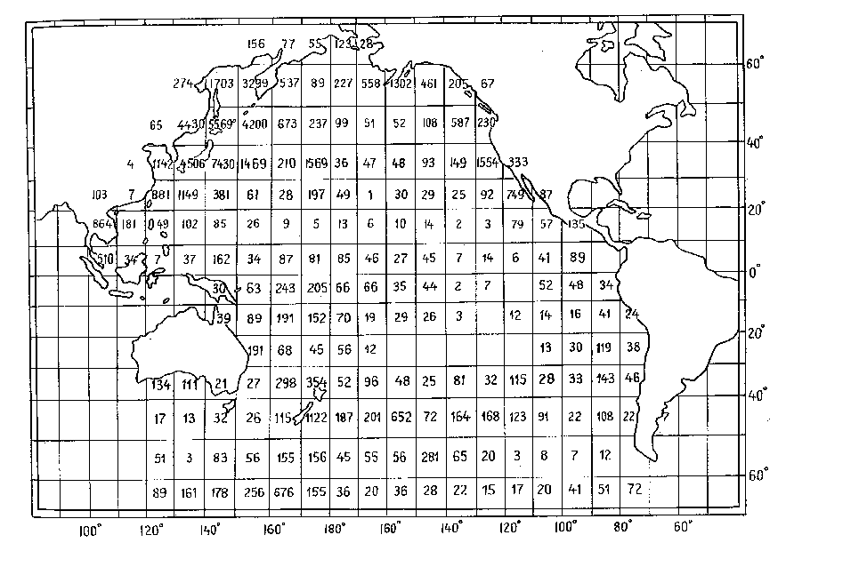
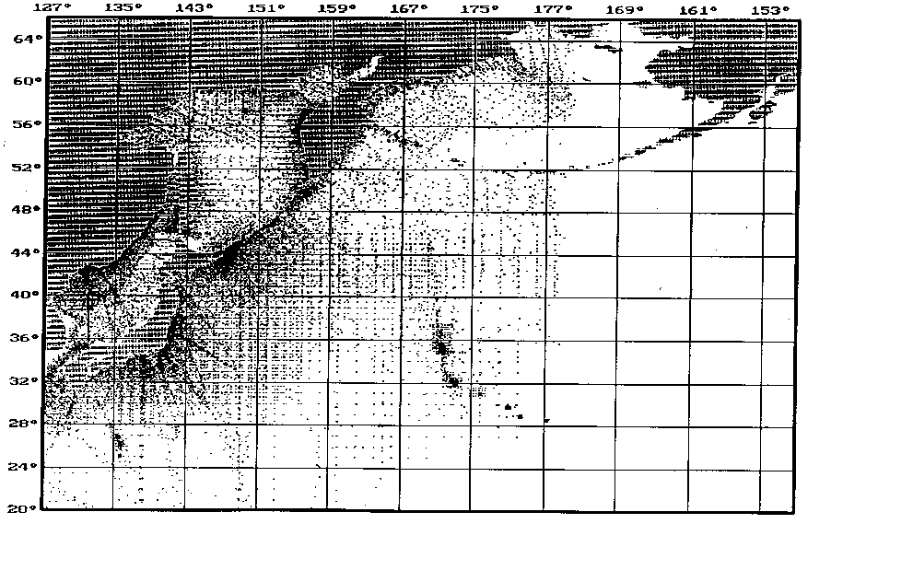

Fig. 1. Distribution of serial stations made by TINRO in 1952-1992

