Oceanographic Research and Data Management in Japan
- Japan Oceanographic Data Center (JODC) -

- Introduction

Japan Oceanographic Data Center (JODC) established in the Hydrographic Department, Maritime Safety Agency (the predecessor of Japan Coast Guard), in 1965 in according with the resolution adopted by the IOC of UNESCO in 1961 as well as the reports of the Council for Marine Scientific Technology of Japan in 1963 and 1964.

Since its establishment, JODC has been fulfilling the role of the synthetic marine data bank of Japan in acquisition of marine data obtained by various marine research institutes and organizations concerned in Japan and in providing users with these data.

In addition, JODC has been carrying out international services as the National Oceanographic Data Center of Japan under the framework of International Oceanographic Data and Information Exchange (IODE) promoted by IOC, and is also in charge of the Responsible National Oceanographic Data Center (RNODC), which manages the Data from international project such as the IOC Regional Committee for the Western Pacific (WESTPAC) programme and so on.

- Oceanographic Research

According to the investigation by the JODC, there are about 150 marine science organizations in Japan that are regularly operating marine research activities, and approximately 160 research vessels belong to them. They carried out more than 900 research-cruises in 2000 fiscal year.

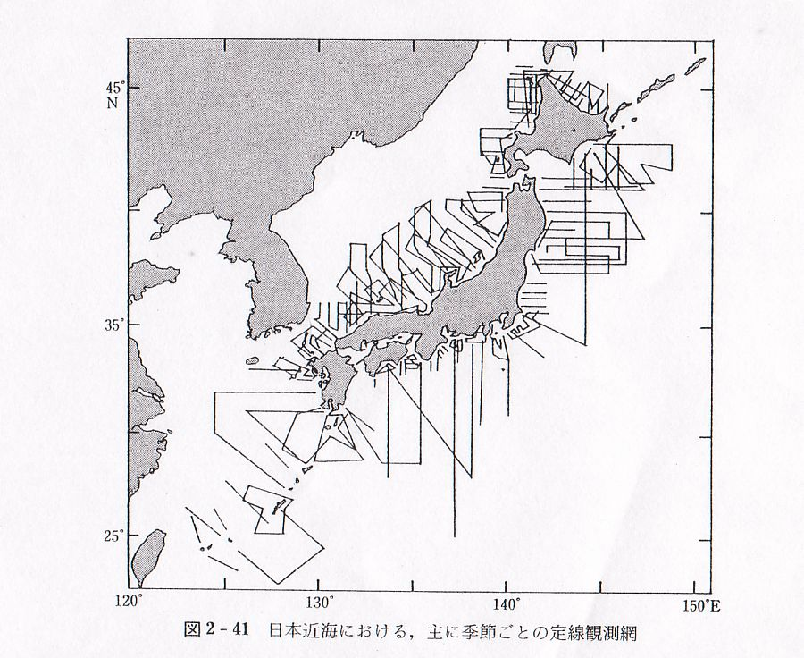
The major organizations are shown as following and the main regular line observations have been operating every month or season by them as indicated in Fig.1.

- Japan Coast Guard
- Meteorological Agency
- Fisheries Agency and
Fisheries Experimental Station
- Defense Agency
- Ministry of Education, Culture,
Sports, Science and Technology
- Ministry of Environment
- Geographical Survey Institute
- Universities

Fig.1. Marine regular observation lines in Japan
3. Data Management

Although a national law that researcher or institute must submit their observed data to data centers has not been established in Japan yet, the Council for Ocean Development expressed the necessity for reinforcement of the JODC as the oceanographic data bank of Japan in 1981. JODC has been holding the domestic-group session for oceanographic data exchange, which consists of the representative from main Japanese research organization and institutes every year in order to discuss the data management and exchange activities in Japan.

The oceanographic data which we received, are given several data processes, such as duplication check, standardizing data format, quality control etc. After the processes, we archive the data in the JODC database for user service, and we have regularly sent the received data to the data centers identified by the IODE system such as the WDC for Oceanography.

3-1. Data Holding in JODC

The volume and type of data available at JODC are presented in the table below:

Serial Station Data | 327,944 stn 1900- | Tidal Current | 7,562 stn 1935-
MBT/XBT/DBT | 645,183 stn 1955- | Hourly sea level height | 120 stn 1961-
STD/CTD | 104,438 stn 1973- | Tidal harmonic constants | 7,562 stn 1928-
BATHY/TESAC (IGOSS) | 3,985,327 stn 1982- | Marine biology | 38,752 stn 1951-
Current by GEK | 192,382 stn 1953- | MARPOLMON | 122,276 stn 1974-
Current by ship drift | 85,055 stn 1907- | Wave (Visual obs. on board) | 617,901 stn 1978-
Current by ADCP | 3,303,500 stn 1985- | Wave (Offshore fixed point) | 63 stn 1973-
Current by ARGOS Buoy | 275 buoys 1987- | MGD77 data | 148 cruises 1953-
Moored current meter data | 135 stn 1979- | Bathymetry data | 1,839,182 stn 1920-
(Number of stations by Japanese organization, except MGD77 data)
Tab.1. Volume and type of data available at JODC

3-2. GODAR Related Activities

JODC has already started activities related with GODAR-WESTAPC in Japan. As the result of that, we have found or received many historical oceanographic data from the Japanese research institutes as shown in Tab.2.

Additionally, JODC has been investigating the historical data that is not digitized in Japan Hydrographic Department since last year. As a result, approximately 10,000 Serial Station data observed by the Imperial Navy from 1923 to 1944 has been found. In addition, we hold Hourly Sea Level Height data, which have not been digitized. Its volume is more than 2,000 months from 1939 to 1964 about 20 stations in Japan. These data will be digitized and added to the JODC Database.

Name of Institute | Description of Data | Status
Fishery Department,  Hokkaido University | 7,496 profiles of oceanographic observation results from 1957 to 1994 | Digitized
Tohoku National Fisheries Research Institute | 17,547 stations of Zooplankton data in the North West Pacific Ocean from 1949 to 1990 | Digitized
Ocean Research Institute, University of Tokyo | Water sampling data and CTD data obtained by more than 40 cruises | Processing
National Environmental  Research Institute | Marine environmental monitoring data at the coastal area of Japan from 1971 to 1998 | Processing
Chiba Environmental  Research Center | About 5,000 Marine biology (plankton) data in Tokyo Bay from 1983 to 1994 | Processing
Tab.2. Status of GODAR activity at JODC

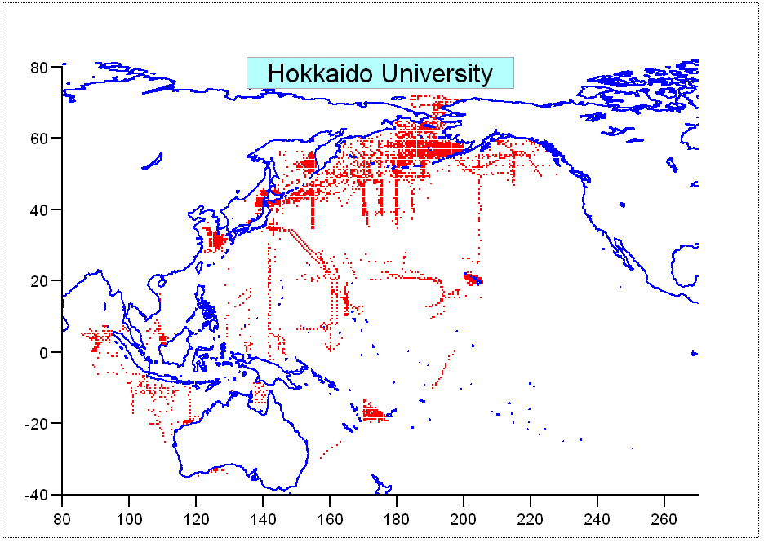
Fig. 2. Data Distribution Map obtained by Hokkaido University
The stations observed by Hokkaido University from 1957 to 1994 are shown in Fig.2.

Other activities concerning the oceanographic data rescue and archaeology in Japan are carrying out by Japan Meteorological Agency (JMA) and National Research Institute of Fisheries Science (NRIFS).

Japan Meteorological Agency
“The Kobe Collection” Dataset (CD-ROM), which is collected and stored by the Kobe Marine Observatory from 1890 to 1960, published by JMA. The Dataset contains a huge number of historical marine meteorological data observed by voluntary ships.

National Research Institute of Fisheries Science
Since 2001, the NRIFA has been carrying out the digitalization of the historical marine data such as Serial station data; Offshore fixed point surface temperature, marine biological data and so on.

4. Conclusion
The importance of promoting the GODAR program in the region was recognized again at the International Conference for the International Data and Information Exchange in the WESTPAC region 1999 (ICIWP’99) held in Malaysia. As the RNODC for WESTPAC, JODC will be promoting the GODAR-WESTPAC project actively.

